JFA Purple Orange Submission
To the South Australian Legislative Council Select Committee on Disability and Access to Education on Access to the South Australian Education system for students with disabilities.

Submitter details
JFA Purple Orange
104 Greenhill Road
Unley SA 5061 AUSTRALIA

Telephone: + 61 (8) 8373 8333
Fax: + 61 (8) 8373 8373
Email: admin@purpleorange.org.au
Website: www.purpleorange.org.au
Facebook: www.facebook.com/jfapurpleorange
Contributors
Georgina Edwards, Project Officer
Dr Mike Haines, Policy Officer
Julia Farr Youth – Youth Advisory Group
Jackie Hayes, Leader Social Policy and Initiatives

About the Submitter
JFA Purple Orange is the social policy arm of the Julia Farr Association Inc. We are a non-government, social profit organisation that conducts research and engages in dialogue with people with lived experience of disability to develop policy and practice. Our work is anchored on the principles of Personhood and Citizenhood.

© September 2015 Julia Farr Association Inc.

Contents
1. The Inquiry 4
2. Introduction 4
3. Disability Standards for Education 5
4. United Nations Convention on the Rights of Persons with Disabilities (UNCRPD) 6
5. Our Approach to this Submission 6
6. Key Principles 7
7. The Experience of Students Living with Disability, their Families and Advocates 8
8. Inclusive Education 8
9. Survey Outcomes 9
10. Recommendations to Improve Access to the South Australian Education System for Students Living with Disability, their Families and Supporters 17
10.1. Support a single inclusive education standard, with all students afforded the opportunity to attend their local neighbourhood school 18
10.2. Invest in teacher capacity building through training to learn about disability and to grow their capacity to teach a diverse class of students 19
10.3. Invest in creative ways of supporting young people living with disability such as the Circles Initiative 21
10.4. Ensure every student and their support network in South Australia has access to transition support such as the My Future: My Life initiative run by Centacare in Queensland 22
10.5. Expand Julia Farr Youth Mentoring to ensure that every student is supported to believe in themselves and the possibility of a good life 22
10.6. Ensure every person can access the school’s facilities, equipment and curriculum 23
10.7. Undertake annual independent social and access audits of schools 24
10.8. Urgently investigate individualised needs-based funding support for students and funding for schools 25
11. Conclusion 27
12. Summary Recommendations 28
13. Request to meet 29

The Inquiry

JFA Purple Orange and Julia Farr Youth applauds the Parliament of South Australia’s Select Committee on Disability and Access to Education for launching this inquiry, and their commitment to improving access to the South Australian education system for students living with disability, their families and support networks.

Terms of Reference:
A Select Committee of the Legislative Council has been established to inquire into and report on access to the South Australian education system for students with disabilities, their families, and support networks, including:
(a) The experience of students with disabilities, additional learning needs and/or challenging behaviours, and their families and advocates in the South Australian education system, including early childhood centres, junior primary, primary and high schools;
(b) The experience of discrimination, including victimisation and harassment, of students with disabilities, including, but not limited to, educational institutions failing to provide students with the support needed to reach their full academic potential on an equal basis with non-disabled students;
(c) The experience of segregation, restraint, lack of social opportunities and inadequate supports for personal care requirements, and other personal care routines such as toilet use for students with disabilities;
(d) The current level of initial and in-service training for teachers and other staff regarding students with disabilities, and suggestions for broadening and improving such training;
(e) The appropriateness or otherwise of school based policies and funding mechanisms for behaviour management for students with disabilities; and
(f) Any other related matter.
We have based our submission on the issues outlined in the Terms of Reference.

Introduction

JFA Purple Orange is the social policy agency of the Julia Farr group, a trio of social profit, non-government organisations based in South Australia, working to improve the life chances of people living with disability. We are an independent, non-government organisation that fosters innovation, shares useful information, and promotes policy and practice that support and improve the life chances of people living with disability.

JFA Purple Orange is not a service provider – we deliver research, evaluation and information services anchored upon the stories and experiences shared with us by people with a lived experience of disability and others in their lives. One of the ways we do this is through our initiative Julia Farr Youth.

Julia Farr Youth (JFY) is a policy and initiatives group comprising eight young people living with disability. Their work focuses on issues affecting young people living with disability and is anchored on the expectations evident in the United Nations Convention on the Rights of Persons with Disabilities (UNCRPD). The work of JFY has included policy submissions, consultancy to government and other stakeholders on relevant issues, and the development of initiatives that can help advance the life chance of young people living with disability; this has included a Julia Farr Youth Mentoring, an initiative that has won multi-year funding and benefited many young South Australians living with disability.

Disability Standards for Education

The Disability Standards for Education 2005 (the Standards) clarify the obligations of education and training providers and seek to ensure that students living with disability can access and participate in education on the same basis as other students. The Standards are formulated under the Disability Discrimination Act 1992 and came into effect in August 2005.
The objects of these Standards are:
a. To eliminate, as far as possible, discrimination against persons on the ground of disability in the area of education and training; and
b. To ensure, as far as practicable, that persons with disabilities have the same rights to equality before the law in the area of education and training as the rest of the community; and
c. To promote recognition and acceptance within the community of the principle that persons with disabilities have the same fundamental rights as the rest of the community.
We note that the Disability Standards for Education 2005 have recently been reviewed and a report on the results of the review is due in the near-term; we hope the review process will help inform the Select Committee’s work.

United Nations Convention on the Rights of Persons with Disabilities (UNCRPD)

There is national recognition, through ratification of the UNCRPD by Australia in July 2008, that all people living with disability have the right to access inclusive, quality education. Under Article 24, the United Nations Convention on the Rights of Persons with Disabilities (UNCRPD) says it will ensure:

- Persons with disabilities are not excluded from the general education system on the basis of disability, and that children with disabilities are not excluded from free and compulsory primary education, or from secondary education, on the basis of disability;
- Persons with disabilities can access an inclusive, quality and free primary education and secondary education on an equal basis with others in the communities in which they live;
- Reasonable accommodation of the individual’s requirements is provided;
- Persons with disabilities receive the support required, within the general education system, to facilitate their effective education;
- Effective individualized support measures are provided in environments that maximize academic and social development, consistent with the goal of full inclusion.

JFA Purple Orange supports the implementation of each of these articles.

Our Approach to this Submission

Our submission focuses on the values, matters of concern and experiences of JFA Purple Orange drawn from discussions with people living with disability, parents and supporters, each of whom has an understanding of the significant impact education has on the lives of young people living with disability.
Our approach to this submission has involved:
- consultation with JFY members about their personal experiences of school
- a survey seeking the opinions of parents and supporters of children living with disability
- a survey seeking the opinions of past and present school students living with disability
- a review of recommendations JFY made to the government after their 2014 National Youth Conference for young people living with disability.

Key Principles

The work of JFA Purple Orange is anchored on the principles of Personhood and Citizenhood and is guided by human rights values and social inclusion. Every human being seeks to build a good life for themselves. As set out in our Model of Citizenhood Support (the Model), a good life might be characterised by the presence of:
- Authorship of an individual’s own life, termed Personhood (often described as control and choice)
- Having valued roles in community life and the economy, termed Citizenhood (often described as inclusion).
A good life largely depends on the availability of life chances – the assets and opportunities available to a person. Unlike citizenship, Citizenhood is a dynamic experience: it can rise and fall depending on the person’s circumstances. The extent to which any person can naturally take up Personhood and Citizenhood is influenced by the degree to which that person lives with vulnerability. For the purposes of this submission we define vulnerability as the presence of circumstances that can adversely impact on the person's capacity to build their own lives and the person's capacity to take up valued roles in community life and the economy. The quality of education a person receives can have a major impact on this.
The Model refers to an intentional set of arrangements that authentically advance a person’s life chances towards Citizenhood, in keeping with each person's lifestyle choices, including education. The Model provides a comprehensive contextual framework for organising policy and practice in support of people living with disability. It asserts that our life chances comprise four different, but interrelated, types of assets we can call upon, termed the Four Capitals. These are: Personal Capital (how the person sees themselves), Knowledge Capital (what the person knows and can apply), Material Capital (money and the tangible things in our lives) and Social Capital (having people in our lives who we know and know us). These apply to any person and can help explain what might be helpful for someone to build a good life for themselves. It is worth noting that each of these types of assets is involved when a person is educated.

The Experience of Students Living with Disability, their Families and Advocates

The JFY Conference Report (2014) highlighted that education is about getting the best possible start in life. It is about discovering who a person is and what they can become, building knowledge and skills, meeting people, building networks and preparing a person for their future. It is about having choice and control in a person’s life, and for every person to have the opportunity to participate in their local community and to attend the school of their choice. However, despite these ideas, our education system is not doing so well.
Some young people living with disability get a “special education” that can separate them for at least part of the day from their non-disabled peers. This can make it tricky to build peer networks because students do not have regular contact with their neighbourhood peers.

Other young people and their families report experiencing difficulties at mainstream schools – difficulties getting around, difficulties getting enough supports and difficulties with “fitting in”, including bullying. This is not good for an education. An education is meant to assist with building confidence, developing who a person is and what they want, and set people up for employment as a productive, contributing adult.

Inclusive Education

“More information [should be] given to educators about studies that have shown the benefits of inclusion. All teachers at a school need some insight as there will be contact with the child in the yard, and questions by other students. Families need to know their rights to have a choice as to where their child is educated, and that their child does not have to reach a certain standard to be allowed into a school.”
JFA Purple Orange gives unequivocal support for inclusive education (i.e. ‘mainstream education’) in the South Australian education system (subject to the wishes of parents/primary carers and students living with disability). We support genuine choices for education options for young people living with disability, and particularly opportunities for inclusion in local mainstream schools as a genuine option for successful inclusion. We endorse truly collaborative relationships between parents, students living with disability, schools, school communities and school staff and support the work undertaken by teachers, principals and support workers, often in difficult circumstances, that support and enable inclusive education.

We acknowledge and support, in general, the South Australian public and independent school sector’s policies and ongoing initiatives for enabling inclusive education in South Australia such as the work the Ministerial Advisory Committee: Students with Disabilities and other local management efforts and actions that reinforce and promote inclusive education.
Finally, JFA Purple Orange supports the provision of appropriate and adequate funding, training, equipment and facilities for schools to be able to provide inclusive education for the benefit for all students.

Survey Outcomes

We undertook two online surveys to collect the perspectives of past and present South Australian school students; and of parents and supporters. Seventeen current or past students, and 49 parents or supporters completed the surveys. Of these, 36.3 per cent were associated with mainstream Government schools; 22.7 per cent with mainstream independent schools; 21.2 per cent with a disability specific school (sometimes called a special school), and 19.7 per cent with another educational option (eg disability unit in a mainstream school; correspondence school).
Responses for a series of questions are provided below. For each question a graph of the parent/supporter responses is provided on the left, and a graph of the current or former student’s responses is provided on the right.

The experience of students living with disability receiving adequate support at school to reach their full academic potential

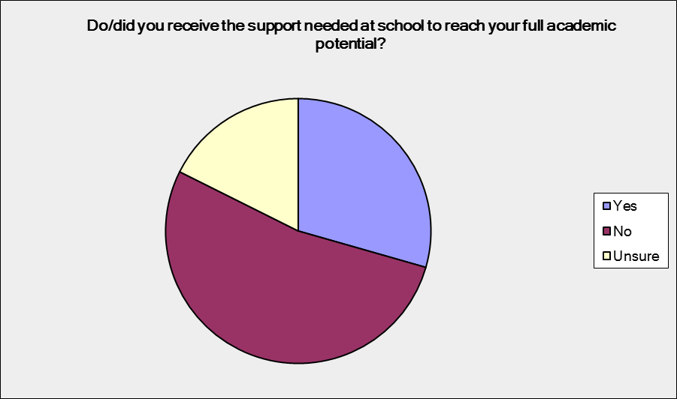
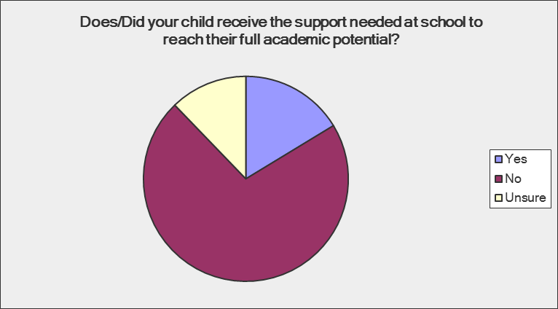

Results indicate:
- 71.43 per cent of parents and supporters responded that their child does/did not receive adequate support at school to reach their full academic potential; 12.24 per cent of parents and supporters were unsure and 16.33 per cent felt their child did receive adequate support to reach their full potential.
- 52.94 per cent of current or former students felt they did not receive adequate support; 12.65 per cent were unsure and 29.41 per cent felt they did receive adequate support.
One parent commented:
“[I have had] mixed experiences. Some teachers (and principals) did NOT want him [my son] there and took every opportunity to send him home, emphasise the negative, have him work outside of the class with the SSO instead of including him within the class and excluding him from activities. It often took 'detective work' on my part to find out that he was spending a lot of time out of class as I was not informed. Other teachers have gone out of their way to be encouraging, and facilitate great inclusion, modify work and keep me well-informed.”

The experience of students living with disability and segregation at school
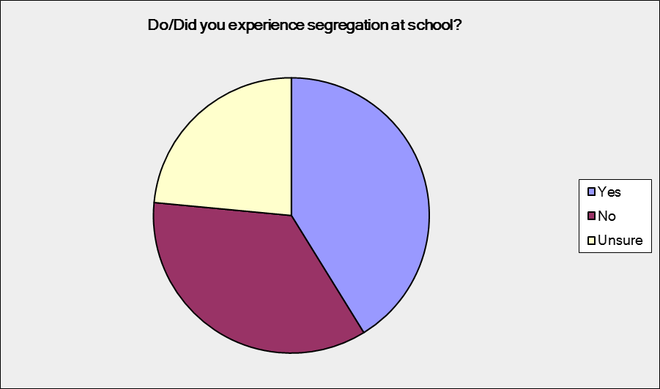
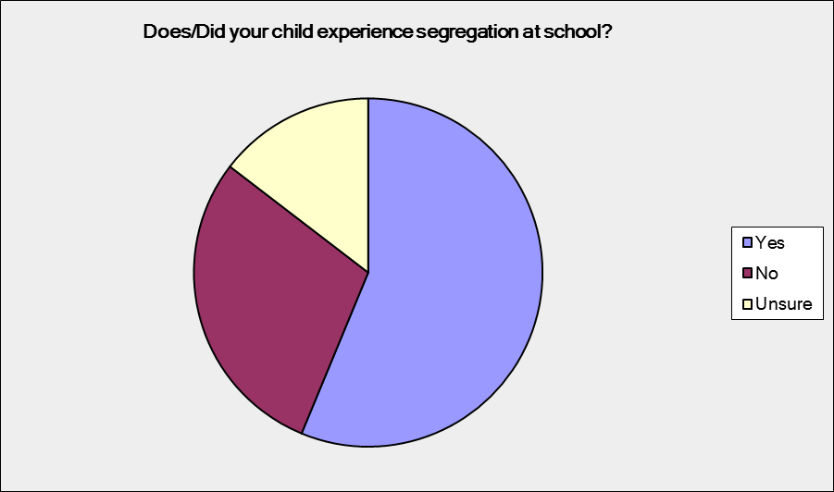

Results indicate:
- 56.25 per cent of parents and supporters responded their child does/did experience segregation at school; 14.58 per cent were unsure and 29.17 per cent stated their child had not experienced segregation at school.
- 41.18 per cent of current or former students indicated they did experience segregation at school; 23.53 per cent were unsure and 35.29 per cent stated they did not experience segregation at school.
Respondents commented:
“Students are not intentionally segregated; however with certain disabilities comes inabilities to socialise and be involved in group work, through access, communication difficulties and inherent abilities.”
“My child was put in [a] separate room with a handful of other students with special needs. These students were pretty well ignored by the rest of the school. [They] were not even photographed for the annual school magazine two years in a row.”

The experience of students living with disability and restraint at school
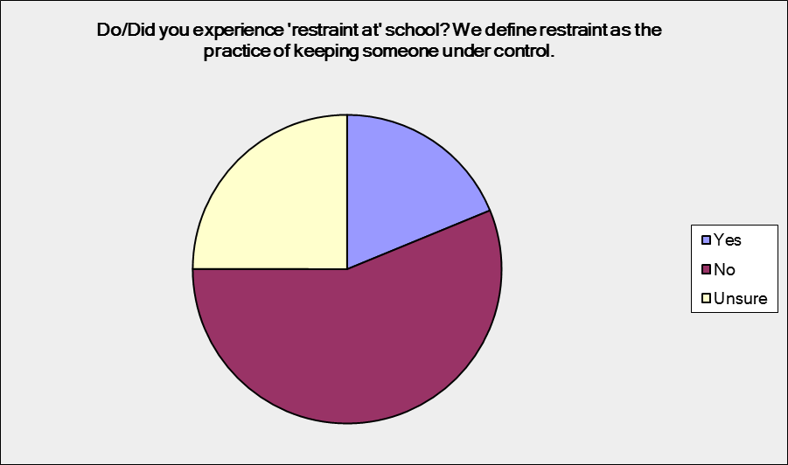
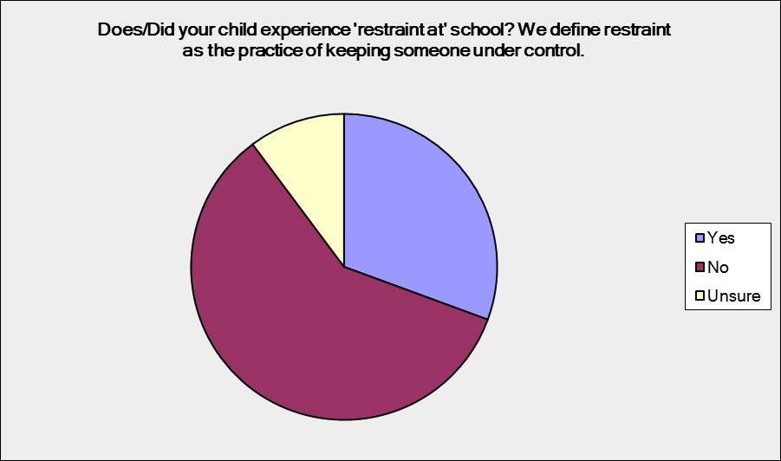

Results indicate:
- 30.61 per cent of parents and supporters responded their child had experienced restraint at school; 10.2 per cent of parents and supporters were unsure and 59.18 per cent stated their child had not experienced restraint.
- 18.75 per cent of current or former students indicated they experienced restraint at school; 25 per cent were unsure, and 56.25 per cent said they did not experience restraint.
Numerous parents commented on various types of restraints:
“Frequent restraints [used] instead of getting expert help or using methods and visuals proven to be effective. Restrained by up to five staff including one male employed for that specific reason but never discussed with parents.”
“He was put in a calm down room which was locked, he hit his head, his nose bled, he was dehydrated.”
“No forced control, but sometimes she is put in sick or sensory room if non-compliant when the teachers or SSOs can't be bothered with her.”

The experience of students living with disability and limited social opportunities at school
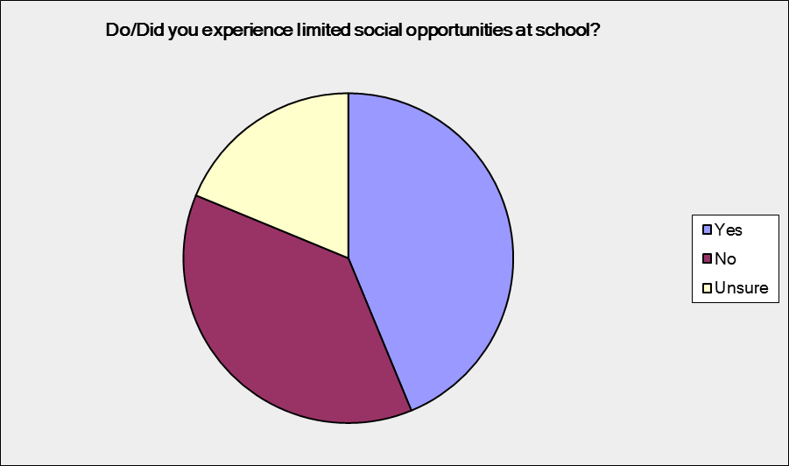
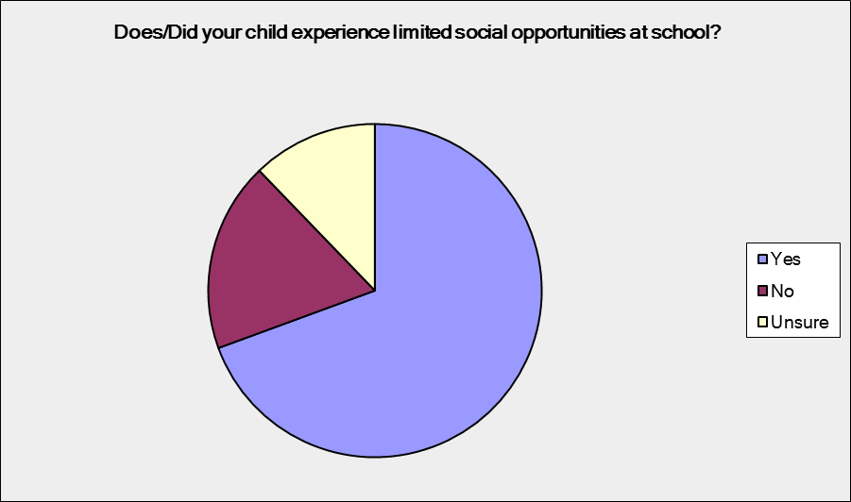

Results indicate:
- 69.39 per cent of parents and supporters responded their child had experienced limited social opportunities at school; 12.24 per cent of parents and supporters were unsure and 18.37 per cent stated their child had not experienced limited social opportunities at school.
- 43.75 per cent of current or former students indicated they experienced limited social opportunities; 18.75 per cent were unsure, and 37.5 per cent said they did not experience limited social opportunities.
A parent commented:
“He wasn't having the opportunity to sit with the other children and teachers in a social setting to have his lunch due to no reason that he keeps wanting to get up from the table. This is not helping him at all with his social skills by locking him in a room so they don't have to be bothered in assisting him with sitting down when eating. I find that even the staff spend little time with him to help improve his social opportunities.”

The experience of students living with disability having adequate support for personal care requirements or any other personal care routines when at school

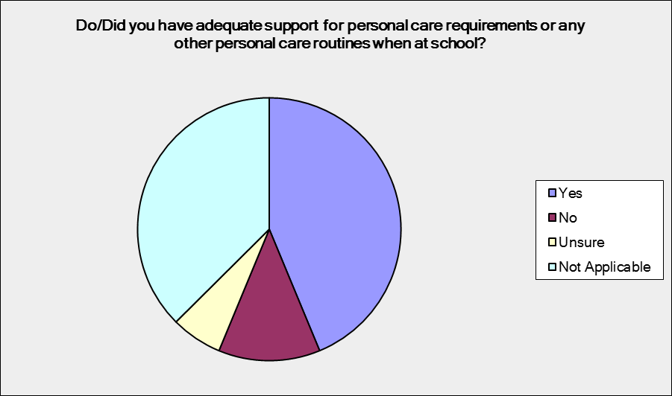
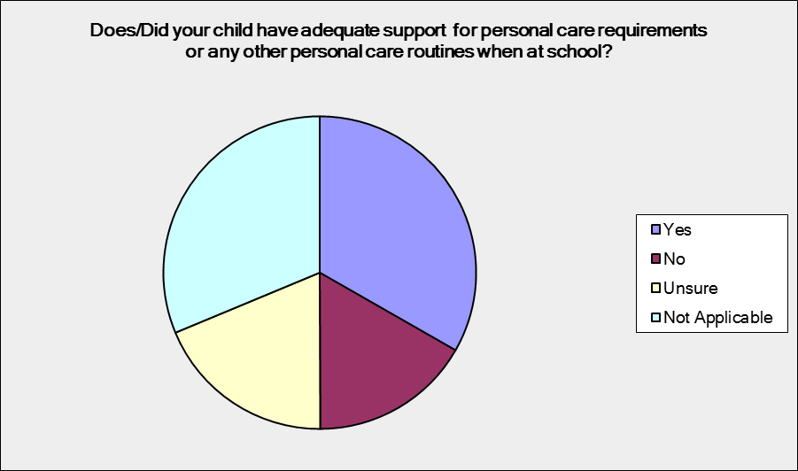
Results indicate:
- 16.67 per cent of parents and supporters responded their child did not receive adequate support for personal care requirements when at school; 18.75 per cent of parents and supporters are unsure, 31.25 per cent of parents and supporters felt this question was not applicable and 33.33 per cent of parents and supporters felt their child received adequate support for personal care requirements when at school.
- 12.5 per cent of current or former students indicated they did not receive adequate support for personal care; 6.25 per cent were unsure; 43.75 per cent felt they received adequate support and for 37.5 per cent of respondents it was not applicable.
Survey respondents indicated:
“Toileting is worked around the school’s schedule not the student.”
“My child was not allowed to be toileted when needed, it was based on staff availability. My child was not given her nutrition when needed it was based on staff availability. The staff were turning her oxygen off because they didn't want to take responsibility for it.”

The current level of training for teachers and other staff at school

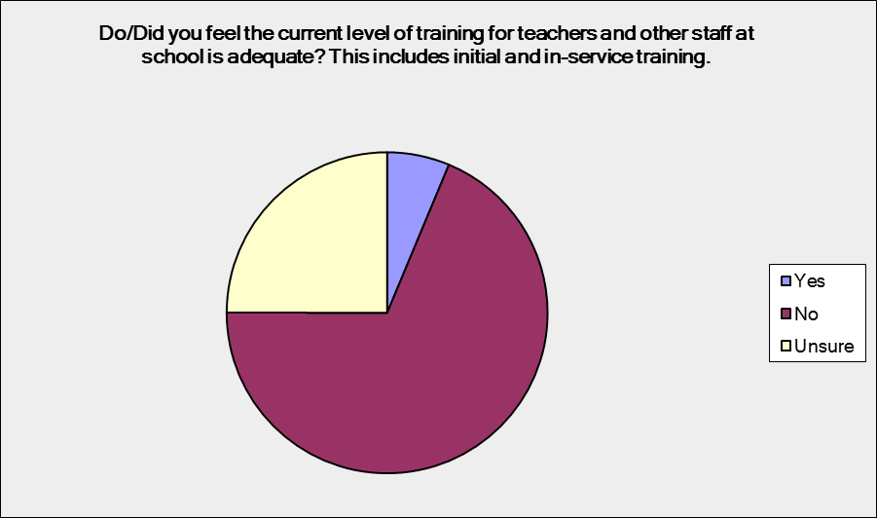
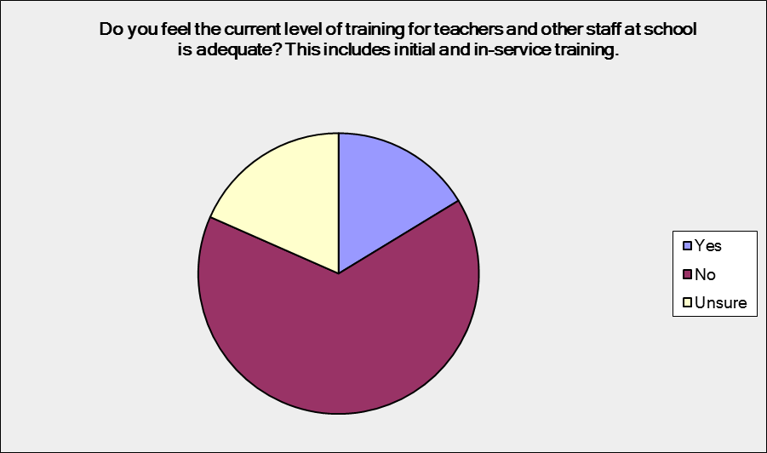
Parent responses: Student responses:

Results indicate:
- 65.31 per cent of parents and supporters responded the current level of training for teachers and other staff at school is not adequate; 18.37 per cent of parents and supporters were unsure and 16.33 per cent felt the current level of training for teachers and other staff was adequate.
- 68.75 per cent of current or former students felt the current level of training for teachers and other staff at school was not adequate; 25 per cent were unsure and 6.25 per cent felt the current level of training for teachers and other staff was adequate.

Respondents commented:

“There are insufficient topics revolved around disability in University teaching degrees, the same also applies when it comes to ongoing professional development about disability generally and also the variations within and between disability.”

“We have been lucky to have one teacher in grade 4 who was special needs trained. Boy, can you tell the difference!”

School funding for adequate behaviour management
Parent responses: Student responses:

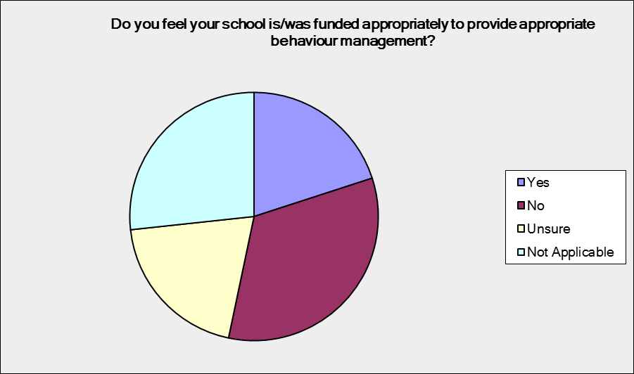
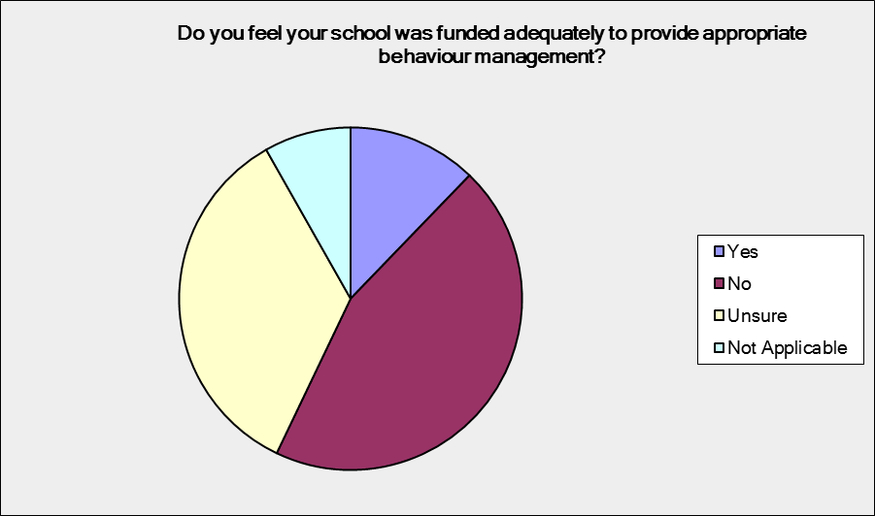

Results indicate:
- 44.9 per cent of parents and supporters responded that schools were not funded adequately to provide appropriate behaviour management; 34.69 per cent of parents and supporters were unsure, for 8.16 per cent this question was not applicable, and 12.24 per cent of parents and supporters felt schools were funded adequately for behaviour management.
- 33.33 per cent of current or former students felt that schools were not funded adequately to provide appropriate behaviour management; 20 per cent were unsure, 20 per cent felt that schools were funded adequately for behaviour management; for 8.16 per cent this question was not applicable.

One parent commented:
“My daughter has significant challenges as do four of her classmates, I believe the teacher struggles as he has a class of 30 children and limited SSO support in class. It is very difficult for him to follow Positive Behaviour Support Plans as he is time poor due to the number of children, and differing needs, in the class.”

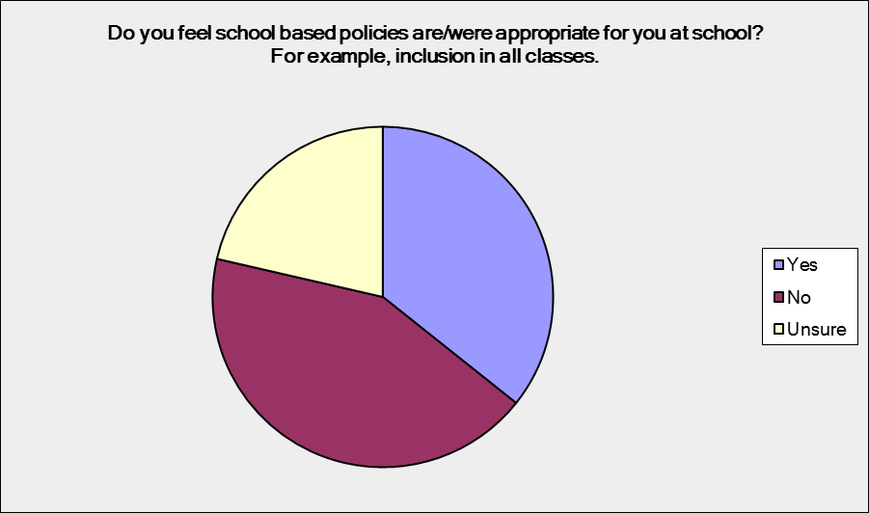
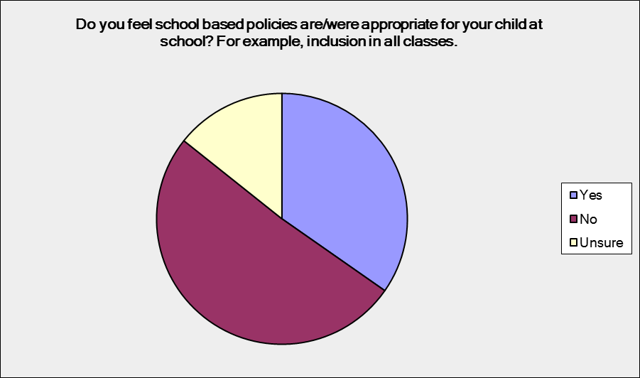
Appropriate school-based policies

Results indicate:
- 51.02 per cent of parents and supporters responded that school based policies were not appropriate for their child; 14.29 per cent of parents and supporters were unsure and 34.69 per cent stated that school based policies were appropriate for their child.
- 42.86 per cent of current or former students felt that school based policies were not appropriate for their needs; 21.43 per cent were unsure and 35.71 per cent stated that school based policies were appropriate.
Respondents commented:
“I feel this way because they were inflexible and uncreative in their approach. Neglecting to be accommodating around timetable scheduling is an example of this.”
“Until school based policies reflect 'Disability Standards in Education' and 'Disability Discrimination Act' it will be difficult to have any faith that education sectors are willing to conform. The Convention on the Rights of the Child should also be considered and reflected in policies.”

Recommendations to Improve Access to the South Australian Education System for Students Living with Disability, their Families and Supporters

Recommendations have been based on the input from young people living with disability, parents and supporters of young people living with disability, JFA Purple Orange and Julia Farr Youth.

Support a single inclusive education standard, with all students afforded the opportunity to attend their local neighbourhood school

“We need to ensure that inclusive education is not a privilege but is a right for all students.”
Every child should have the choice to attend their local neighbourhood school and get a successful education, where success is characterised by authentic inclusion across all areas of school life, and where the student has the best possible chance of transitioning to a productive adult life.

All education should be based on the assumption that all children have the capacity to grow and learn and this will best happen in supportive inclusive neighbourhood schools. By having a separate system of specialised schools, we are setting up a different path of expectation - in the children who attend those schools, in their families, and in the broader community.
Inclusion Alberta is an example of an inclusive education model that is working well. They advocate for quality inclusive education where children living with disability are welcomed into mainstream classrooms at their local school. Children living with disability, their peers and teachers receive the support they need to be successful. Curriculum and instruction are individually adapted and children participate in all school activities.
Inclusion Alberta works with teachers, schools and school districts to develop quality inclusive education from pre-school to high school. During the year Inclusion Alberta offers workshops on inclusive education for school personnel and parents that are typically led by internationally acclaimed authorities on inclusive education. They also provide consultation to schools and teachers and have a vast array of inclusive education resources for the regular classroom teacher.
Inclusion Alberta believes parents should be able to freely choose an inclusive education for their child. If families encounter poor quality inclusive education or resistance, Inclusion Alberta will provide advocacy resources for as long as it takes to ensure a successful outcome and have close to a 100 per cent success rate.

Invest in teacher capacity building through training to learn about disability and to grow their capacity to teach a diverse class of students

“In my school days some teachers would put me in a special unit; my SSO would misinterpret what was said which lead to me failing my classes … we need good quality training for teachers so that students can reach their potential.”
“More commitment from State and Federal governments to provide support and training for staff in this area would be a good thing”.
JFA Purple Orange supports the work of teaching and ancillary staff in South Australia. We recognise the challenges and demands, as well as the inestimable benefits of providing education to the children and young people of our wider community. We recognise the expertise, professionalism and dedication of individuals in the education sector. We applaud the efforts of many educators, leaders and teachers and support staff, to make inclusive education a reality in our education system.
Obtaining graduate and/or post-graduate teaching degrees, teaching accreditation and screening is a large investment undertaken by both individuals and the State. Benefits accrue to current and future members of our community by these investments. This investment, at least for individuals, may grow considerably if, for example, proposals to deregulate University fees, or continued reductions in Commonwealth funding for student places, continues. The recruitment, placement and ongoing professional development of educators should not be placed in jeopardy by governmental or institutional policies. In short, people attracted to the education sector, who are committed to inclusive education, should not have barriers erected for them by increased, or increasing, costs of education or other inhibiting initiatives.
Teaching/education Degrees offered by universities in South Australia are, understandably, structured on developmental/schooling stages for children. Core subjects and units are important components of Degree courses at the undergraduate level. These courses are subject to accreditation. Flinders University provides courses of study for the Bachelor of Education/Bachelor of Disability Studies for Middle/Secondary school, as well as graduates wishing to teach in Early Childhood and Special Education. Flinders University also offers postgraduate degrees for those wishing to specialise in special education. Degrees are offered for students who are teaching graduates and those who are not. It appears South Australia is well served for courses of study that prepare educators for educating young people living with disability.
JFA Purple Orange would, nonetheless, support the inclusion of inclusive education (e.g. as a unit of study) as a necessary part of undergraduate courses of study for all aspiring teachers/educators in South Australia. Furthermore, we would support any such initiatives that have practical relevance for teaching practices related to students living with disability at all levels of the education system.
JFA Purple Orange supports the work of the Department of Education and Child Development, including the work of departmental units such as the Special Education Resource Unit (SERU). The work of SERU supports best teaching practices as well as the distribution of relevant support services, resources and information to teachers educating children living with disability. SERU also provides training for teachers, online or through seminars and workshops.
The necessity of ongoing teacher (and support staff) training to meet the challenges and demands of inclusive education is very apparent.The South Australian Minister for Education, Dr Susan Close, recently announced $700,000 funding for Flinders University to design and teach a specialised postgraduate course in teaching children with autism spectrum disorders (ASD) [in mainstream schools] to 80 teachers from across the State, Catholic and independent school sectors.
We applaud the investment in teacher training and recommend the following to further support this initiative:
- Expand the postgraduate mainstream teacher training on ASD to also include teacher training and inclusive best practice knowledge to support students living with physical, neurological, hidden, mental health and intellectual disability.
- Introduce compulsory inclusive best practice teacher training for undergraduate teachers, not limit this to postgraduate opportunities or specific disability degrees.
- Design and introduce a teaching module that is run by people living with disability who share their experiences with teachers at university and at teacher training/staff development days.

Invest in creative ways of supporting young people living with disability such as the Circles Initiative

“My son has trouble interacting with other children at lunch and recess. I have requested that small organised group activities could be put in place, or by providing an area that children can sit and draw or play board games. I have been told that due to lack of funding and staffing this can’t be done.”
“Kids need more socialising opportunities (not just academic modifications).”
The Circles@School initiative is a trial funded by the Department of Education and Child Development (DECD), independently implemented by the Community Living Project (CLP) Circles Initiative in conjunction with JFA Purple Orange. It aims to provide students living with disability attending mainstream schools and their parents with a network of support and belonging which will assist in strengthening their chances of a successful, inclusive education and participation in their school and local community.
The project aims to assist students living with a disability (aged 4-18) in mainstream classes in government, independent, or Catholic schools to:

- develop a natural, freely given support network of peers which would complement other formal supports already in place
- intentionally develop a circle of friends and acquaintances within and beyond their year level/class to provide social support
- develop a sense of connectedness to peers their age and surrounding environment thus reducing the risk of isolation, bullying and exclusion
- build on support structures in place for social inclusion of students.

In addition, the project aims to develop a support network to assist the adults (parents) in the life of the student to connect with the education system to support the student’s educational journey, and reduce any feelings of isolation and disconnection from the mainstream school community.

Ensure every student and their support network in South Australia has access to transition support such as the My Future: My Life initiative run by Centacare in Queensland

“I went from skipping year nine and being in an accelerated program for students with high intellectual potential to barely scraping a pass in year 12. I had the capability I just needed more support and flexibility. Someone sitting down and planning with me and letting me know options would have helped too, i.e. I never knew that I could have done year 12 over two years.”

My Future: My Life is a ground breaking initiative which encourages and supports Queensland secondary students living with disability to prepare and plan for their life after school. They do this by offering the following support options for students, their parents and supporters, educators and disability professionals:

- Workshops for parents, educators and disability professionals to build their knowledge and capacity to assist students to identify, capture, plan for and pursue their goals for life after school.
- Transition Preparation Support for secondary students living with disability from Years 7-12 (and their parents) to identify their strengths, interests and capacities and to use these to guide their planning for life after school through face-to-face planning sessions. Families get the most benefit from Transition Preparation Support if they have attended a workshop.
- Financial Assistance for students living with disability in years 11 and 12 (or year 10 in some rural and remote locations) to purchase resources needed to pursue their goals for life after school.
For more information about this initiative visit www.myfuturemylife.com.au

Expand Julia Farr Youth Mentoring to ensure that every student is supported to believe in themselves and the possibility of a good life

In 2009 Julia Farr Youth designed and implemented Julia Farr Youth Mentoring, a peer-to-peer support initiative for young people living with disability. Mentees are aged 11 to 18 and are mentored by other young people aged 18 to 30 who also live with disability. In 2012 the initiative was awarded multi-year funding from the Minister for Education and Child Development and in 2014 expanded to include group mentoring and e-mentoring to meet the demand of interested students living with disability.
External evaluation of the initiative in 2014 identified mentees have experienced increased confidence levels in many areas of their lives, including transitioning to higher education, building social skills and networks, exploring ways to address challenges and becoming more active in their community. Mentees are feeling more informed about life situations and choices, and are making positive decisions based on newfound knowledge.
JFY has also run group mentoring sessions. The group mentoring information sessions provide mentees with the opportunity to chat with mentors with lived experience of disability about topics such as school transition, employment, making friends, dealing with anger and frustration, anxiety and building resilience, rights and leadership, and living on the autism spectrum to name a few. Evaluation has found that young people come away feeling more confident, resilient, resourceful and willing to try something new.

Ensure every person can access the school’s facilities, equipment and curriculum

“There were definitely instances where I would be left downstairs because the lift didn’t work or had to sit out of PE (our school didn’t have health and I would have loved to do P.E. without the physical stuff in year 12) or I had to sit out of home ec. (cooking) because of benches, had to try to learn how to use a sewing machine without being able to use my feet. Also our lift was a stair lift, not an actual elevator for the first three years I was at school which meant I was late and I could never sit with friends, the designs of the classroom pretty much made this impossible too.”
A good example of access was given at the Julia Farr Youth Conference by one of the conference speakers. He told of modifications made for him when he attended school including ramps and handrails and a desk with a drawer for easy access. He said he participated in physical education lessons and played cricket for his school team with the aid of a runner. During exams he had the use of a scribe and someone to explain the question. At university he had an access plan which included automatic extensions to assignments (if needed), the use of automated voice activated software and extra time in exams and tests.

Undertake annual independent social and access audits of schools

JFA Purple Orange recognises that policies will reflect the demands, challenges and opportunities arising from local conditions of schools and their communities and the broader issues of providing education for all students.
We recognise the Department of Education and Child Development has developed policies for Child and Student Wellbeing, School Discipline and Protective Practices. Policies have also been developed for Countering Racism and Bullying, Harassment and Violence. These policies provide all South Australian public schools and school communities with principles and guidelines they are required to work within. Schools, staff, students and school communities are also bound by relevant legislation.
We cannot support policy-related stances by some schools where genuine and substantial efforts are not made to provide genuine options for inclusive education.
Responses to individual needs of some students are frequently a matter of collaboration between the school, parents and/or primary care-givers and other professionals. Each party has an important role to play, in a school setting, in tailoring responses to individual needs.
It is recognised that difficulties, misunderstandings and challenges arise in educating young people. These are not to be underestimated or dismissed. However, concerns about the impacts of disadvantage on children’s development, as well as the prevalence of challenging behaviours in schools are often well founded. Schools require sufficient human and material resources to meet the challenges of preparing young people for life in Australia in the twenty-first century.
These matters highlight the importance of ongoing, relevant, quality training for school staff. This matter gains greater urgency as school roles are projected to increase over the next ten years in South Australia and demand for teachers accordingly.
Feedback from young people and their families is that school policies do not always reflect the reality of the school environment. Over time, reality may drift further and further from the stated policy positions. A yearly independent audit carried out in all schools with students, parents, teachers and principal having input, is one way of ensuring reality matches policy.
Young people are also keen to be involved:
“Create a social inclusion committee within schools made up of students [to] audit schools.”

Urgently investigate individualised needs-based funding support for students and funding for schools

It is of concern to JFA Purple Orange that surveys undertaken by the Australian Education Union (AEU) clearly indicate the problems faced by public school principals in allocating funds. Approximately 80 per cent of principals surveyed have “shift[ed] funds from other parts of their budget to educate students with disability.” Approximately 90 per cent of schools surveyed in South Australia by the Australian Education Union (AEU) stated funds were drawn from other areas of the school budget to fund students living with disability i.e. to fund the inclusion/education of those students without official funding.
The re-allocation of funding, where it occurs, and necessary as it is, also raises the possibility of reducing the availability of funds for in-service teacher training.
AEU surveys also found that teacher’s workloads have increased. The reasons for such increases are many. Significant proportions of surveyed teachers identified two factors of importance: large class sizes and the need for additional support/resources for students living with disability. Both factors contribute to limiting opportunities for in-service teacher training i.e. increased workloads indicate that teachers have less non-contact or training time available to them. Increased workloads include all necessary administrative and professional tasks that are associated with teaching in the early twenty-first century.
South Australian data indicates there are approximately three times more students with unmet needs in schools (i.e. unfunded) than students with funding. These data reinforce, among a number of other important associated matters, the need for in-service training for teachers so that diverse needs in classrooms can be met while also achieving good educational outcomes for all students.
Training for inclusive and diverse classrooms will have a positive impact on in-school/classroom support(s) for students living with disability with potential flow-on effects of reducing the pressure for providing formal supports.
It is of considerable concern that, once again, school funding, or lack thereof, has impacts across a wide range of interdependent matters that affect schools, students and their schooling, and impact, not least, on the promotion of inclusive education and training that supports and enables its implementation in school communities.
Results from our survey show that overwhelmingly 71.43 per cent of parents and supporters responded that their child does/did not receive adequate support at school to reach their full academic potential. A significant boost in school funding would assist with alleviating some of these issues combined with individual funding options for students living with disability. A big part of this is students and their families having control over where money is allocated so that they can have the best possible educational experience.

“For 3/5 of my time during Secondary School I had no staff member to equip me with appropriate seating/table and help me to access my food during recess and lunch breaks and I had to phone call a relative on occasions when I was unable to manage toileting independently.”

“My daughter is only able to attend part time as she requires considerable support and that is all that is funded. We live in a small country town so have limited education choices.”

JFA Purple Orange recommends the Select Committee urgently investigate needs-based funding for South Australian schools. South Australia needs to lead the way in investing in our school system on the basis of need so that all students can get an education which will allow them to participate in our economy as adults. All schools need to be appropriately resourced to deliver a high quality education to every child.

Conclusion
The South Australian education system requires all available support and resources to move to inclusive education in the shortest possible time. The challenges facing students living with disability, as well as all young people, are complex and in some instances, difficult.
The best possible schooling outcomes for all young people, enabling them to participate in their communities, as fully as their abilities and capacities allow, is a pressing issue for the South Australian community.
We consider that principles of inclusive education provide a foundation for all students to achieve positive educational outcomes; young people, in their interactions at school, are important agents in building cultures of inclusion and diversity. As such we consider that inclusive education is a foundational principle for all school communities to actively promote and reinforce environments that are welcoming for all students. Nonetheless, these considerations go hand-in-hand with necessary acknowledgments of other important dimensions in the education system:
“[u]nless macro-strategies are effective in enhancing the quality of teaching and leadership, creating professional learning cultures in schools, and promoting the use of evidence-based methods – in other words, driving micro-reform – they are unlikely to lead to improved quality and equity in our schools.”
We commend the Select Committee for undertaking this work and look forward to its report and recommendations.

Summary Recommendations
We recommend the Select Committee implement as a matter of urgency the following recommendations:
- Support a single, inclusive education standard, with all students afforded the opportunity to attend their local neighbourhood school
- Invest in teacher capacity building through training to learn about disability and to grow capacity to teach a diverse class of students including:
  - Expanding the recently funded postgraduate mainstream teacher training on Autism Spectrum Disorder to also include teacher training and inclusive best practice knowledge to support students living with physical, neurological, hidden, mental health issues and intellectual disability
  - Introducing compulsory inclusive best practice teacher training for undergraduate teachers, not limit this to postgraduate opportunities or specific disability degrees
  - Design and introduce a teaching module that is run by people living with disability who share their experiences with teachers at university and at teacher training/staff development days.
- Invest in creative ways of supporting young people living with disability such as the Circles Initiative
- Ensure every student and their support network in South Australia has access to transition support such as the My Future: My Life initiative run by Centacare in Queensland
- Expand Julia Farr Youth Mentoring to ensure every student is supported to believe in themselves and the possibility of a good life
- Ensure every person can access the school’s facilities, equipment and curriculum
- Undertake annual independent social and access audits of schools
- Urgently investigate individualised needs-based funding support for students and funding for schools.

Request to meet

We would welcome the opportunity to provide additional information as required. We would also value the opportunity to meet with the Select Committee to discuss the submission contents in more detail.

For further information about this submission, please contact:

Robbi Williams
Chief Executive Officer
Julia Farr group
Phone: (08) 8373 8333
Email: admin@purpleorange.org.au

Disability Standards for Education https://education.gov.au/disability-standards-education
Department of Education and Training, 2006. Disability Standards for Education 2005. Department of Education and Training, Barton, ACT. 40pp.
Urbis website. 2015 Review of the Disability Standards for Education 2005. [Undated]. Web. (15 July 2015).
Ibid
Article 24 Education http://www.un.org/disabilities/convention/conventionfull.shtml
Williams, R. (2013), Model of Citizenhood Support: 2nd edition, Julia Farr Association Inc, Unley South Australia
JFY Conference Report http://www.purpleorange.org.au/files/8414/1836/6028/Julia_Farr_Youth_Conference_Report.pdf
JFY Conference Report http://www.purpleorange.org.au/files/8414/1836/6028/Julia_Farr_Youth_Conference_Report.pdf
Survey response
JFY Conference participant
Inclusion Alberta http://inclusionalberta.org/inclusive-education/inclusive-education/
Inclusion Alberta http://inclusionalberta.org/inclusive-education/inclusive-education/
Inclusion Alberta http://inclusionalberta.org/inclusive-education/inclusive-education/
JFY conference participant
Survey results
Times Higher Education website. Economist ‘gobsmacked’ by Australia’s uncapping of fees. (Byline: John Morgan. Date: 24 July 2014). Web. [25 June 2015].
For example, see: Special Education Resources Unit website. What’s Happening. 2015 Special Education Expo 6 – 8th July 2015. (Updated: 22 June 2015). Web. [23 June 2015].
For example, see: Barnes, M.C. & Gaines, T., 2015. Teachers’ Attitudes and Perceptions of Inclusion in Relation to Grade level and Years of Experience. Electronic Journal for Inclusive Education 3(3). Article 3. Online.
Forlin, C., Chambers, D., Loreman, T., Deppeler, J. and Sharma, U., 2013. Inclusive Education for Students with Disability: A review of the best evidence in relation to theory and practice. Australian Research Alliance for Children and Youth, Braddon, ACT: 42 et seq.
Flinders to teach our teachers about autism http://indaily.com.au/flinders-news/2015/08/28/flinders-to-teach-our-teachers-about-autism/ 28th August 2015
Survey
JFY Conference participant
Student survey
My Future: My Life, Think Prepare Plan for life after school, Centacare brochure
JFA Purple Orange http://www.purpleorange.org.au/projects/jfymentoring/
Student survey
For example, see: Shaw, M., 2010. Managing challenging behaviours with children who have additional needs. Putting Children First 34: 21-23.
Laluvein, J., 2010. Parents, Teachers and the “Community of Practice”. The Qualitative Report 15(1): 176-196.
Gialamas, A., Mittinty, M.N., Sawyer, M.G., Zubrick, S.R. and Lynch, J., 2015. Social inequalities in childcare quality and their effects on children’s development at school entry: findings from the Longitudinal Study of Australian Children. Journal of Epidemiology and Community Health. Online. [Published: 31 March 2015].
Dunlap, G., Strain, P., Fox, L., Carta, J., Conroy, M., Smith, B., Kern, L., Hemmeter, M., Timm, M., McCart, A., Sailor, W., Markey, U., Markey, D., Lardieri, S. and Sowell, C., 2006. Prevention and Intervention with Young Children’s Challenging Behavior: Perspectives Regarding Current Knowledge. Behavioral Disorders 32 (1): 29-45.
Weldon, P.R., 2015. The Teacher workforce in Australia: Supply, demand and data issues. Policy Insights Issue 2. Australian Council for Educational Research, Melbourne, Victoria: 5ff.
JFY Conference
Australian Education Union, 2015. Media Release: Abbott Government must act on funding as new report shows huge numbers of students with disability missing out. Australian Education Union Federal Office, Southbank, Victoria: 1.
Australian Education Union, 2015. State of Our Schools Survey 2015. Australian Education Union, Southbank, Victoria. n. pages.
Australian Education Union, 2010. State of Our Schools Survey 2010. Australian Education Union, Southbank, Victoria: 14.
Organisation for Economic Cooperation and Development (OECD), 2005. Teachers Matter: Attracting, Developing and Retaining Effective teachers. Overview. OECD Publishing, Paris, France. 12pp.
Department of Education and Training website. What is the Nationally Consistent Collection of Data on School Students with Disability? (Updated: 23 April 2015). Web. [25 June 2015].
Australian Education Union, 2015. Summary of AEU submission to the Review of Disability Standards for Education 2005. Australian Education Union, Southbank, Victoria: 2.
Student Survey
Parent Survey
Gonski, D., Boston, K., Greiner, K., Lawrence, C., Scales, W. and Tannock, P., 2011. Review of Funding for Schooling - Final Report. Department of Education, Employment and Workplace Connections, Canberra, ACT. 286pp.
Australian Youth Affairs Coalition (AYAC), 2013. Australia’s Youth Matters: Young people talk about what’s important to them. AYAC, Surry Hills, New South Wales. 11pp.
For example, see: Family Advocacy, 2014. Features of an Inclusive School in and Inclusive Education System. Family Advocacy, Epping, New South Wales. 3pp.
For example, see: Bucholz, J.L. & Sheffler, J.L., 2009. Creating a Warm and Inclusive Classroom Environment: Planning for All Children to Feel Welcome. Electronic Journal for Inclusive Education 2(4). Article 4. Online.
Masters, G.N., 2014. Plenary 1 - Quality and Equity through Evidence-based Practice. Paper presented at the Australian Council for Educational Research Conference, Adelaide, August 2014: 15.

