Model of Citizenhood Support
2nd Edition 2013
Robbi Williams

Published by
JFA Purple Orange
104 Greenhill Road
Unley SA 5061
AUSTRALIA

Telephone: + 61 (8) 8373 8333
Fax: + 61 (8) 8373 8373
Email: admin@purpleorange.org.au
Website: www.purpleorange.org.au
Facebook: www.facebook.com/jfapurpleorange
Author
Robbi Williams
Robbi Williams is CEO of the Julia Farr group. Robbi is a psychologist with more than 25 years international experience working across a wide range of social issues, including disability, mental health, ageing and families. This has included service provision, community development, government policy, commissioning, change leadership and advocacy. His work has included agency transition to personalised supports.

As a result of his work, Robbi has developed a range of materials in lifestyle planning and analysis, and in values-based leadership.

JFA Purple Orange
JFA Purple Orange is the social policy arm of the Julia Farr Association Inc. We are a non-government, social profit organisation that conducts research and engages in dialogue with people with lived experience of disability to develop policy and practice. Our work is anchored on the principles of Personhood and Citizenhood.

Access
This publication has been printed in12pt font size for ease of reading for people living with vision impairment. Please contact us if you require a plain text copy of this publication.

Copyright
This publication is copyright. Apart from any fair dealing for the purpose of private study, research, criticism or review, as permitted under the Copyright Act, no part of this publication may be reproduced by any process without written permission.

Requests for re-prints should be directed to JFA Purple Orange, PO Box 701, Unley Business Centre South Australia 5061 Australia

© May 2013 Julia Farr Association Inc.

ISBN: 978-0-9807086-9-1

Contents
1
Contents 3
1.0 Acknowledgments 6
2.0 About this Monograph 7
3.0 Citizenhood 8
4.0 The Experience of a Good Life 10
5.0 Introducing the Four Capitals 12
6.0 Personal Capital 16
6.1 The Elements of Personal Capital 16
6.2 Distance from Personal Capital 17
6.3 Building Personal Capital – Statement of purpose for the helping agency/agent 19
6.4 Upholding and Advancing Personal Capital – Considerations 20
6.4.1 Understanding the Person’s Story – The art of listening 20
6.4.2 Understanding the Effect of Services – The art of reflecting 21
6.4.3 Responding to Personal Service Trauma – The art of healing 22
6.4.4 Assisting a Person to Imagine What Might be Possible and Take Steps Towards It – The art of planning 22
6.4.5 Building a Life – The art of authoring 23
7.0 Knowledge Capital 26
7.1 The Elements of Knowledge Capital 26
7.2 Distance from Knowledge Capital 27
7.2.1 The Issue of Access 27
7.2.2 The Issue of Filters 28
7.3 Building Knowledge Capital – Statement of purpose 30
7.4 Upholding and Advancing Knowledge Capital 31
8.0 Material Capital 34
8.1 The Elements of Material Capital 34
8.1.1 Personal Material Capital 35
8.1.2 Public Material Capital 36
8.2 Distance from Material Capital 37
8.2.1 Distance from Personal Material Capital 37
8.2.2 Distance from Public Material Capital 37
8.2.3 The Notion of the Common Good 38
8.3 Building Material Capital – Statement of purpose 39
8.4 Upholding and Advancing Material Capital – Considerations 40
8.4.1 Upholding Personal Material Capital – Respect and Care 40
8.4.2 Upholding Access to Public Material Capital – Avoiding the Creation of “Special” 41
8.4.3 Advancing Personal Material Capital – Finding Meaningful Paid Work 42
8.4.4 Advancing Personal Material Capital – Creating Personalised Budgets 43
8.4.5 Advancing Public Material Capital – Features of Access in Community Life 45
9.0 Social Capital 48
9.1 The Elements of Social Capital 48
9.2 Distance from Social Capital 50
9.2.1 The Assumption and Impact of Service Recipiency 50
9.2.2 The Problem of Special 51
9.2.3 The Tyranny of Special 53
9.3 Building Social Capital – Statement of purpose 55
9.4 Upholding and Advancing Social Capital – Considerations 57
9.4.1 Upholding Social Capital – The art of the Executive Assistant 57
9.4.2 Advancing Social Capital – The art of introductions 59
9.4.3 Advancing Social Capital – The art of building a welcoming, integrated community life 60
10.0 Surveying a Person’s Life Chances using the Four Capitals 64
11.0 The Interrelationship between the Four Capitals and the Implications for Agency (or Agent) Support; Building an Authentically Helpful Relationship 73
11.1 Twenty Questions about Authentic Helpfulness 74
11.2 Running a Life Chances Helpfulness Audit 90
12.0 Closing Remarks 92

Acknowledgments
I would not have been able to craft this Model of Citizenhood Support without the experience, wisdom and insight shared with me by many people - too many to list here.
However, these are some people I would particularly like to acknowledge for their insights (listed alphabetically). My apologies to anyone I may have accidentally omitted.
- Jayne Barrett
- Dr Simon Duffy
- Pat Fratangelo
- Dr Lorna Hallahan
- Dr Michael Kendrick
- Janet Klees
- Glenda Lee
- Professor Jim Mansell
- Dr Christopher Newell
- John O’Brien
- Mark Pattison
- Lorna Sullivan
- Ross Womersley
I also extend my deep appreciation to JFA Purple Orange for giving me the opportunity to develop this Model. It is a privilege to work with this agency; I am deeply fortunate to have the support of a wise, passionate and energetic board, together with a talented and committed team of co-workers.
Finally, I extend my thanks to the many people I have encountered over the years who are living lives of increased vulnerability, whose triumphs and frustrations have been the primary source of wisdom for my enquiry into life chances.
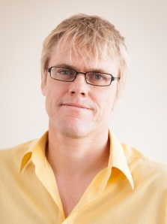
Robbi Williams
Adelaide, May 2013

About this Monograph
The Model of Citizenhood Support 2nd Edition (the Model) is a framework for advancing people into good, valued lives. The Model was first referenced in the Model of Citizenhood Support published by the Julia Farr Association Inc. in 2010. It is based on the premise that each of us wishes to live a good life; a good life is built upon, and maintained through, four key areas of capacity and growth referred to as the Four Capitals.
Throughout the Model we use the term ‘people living with increased vulnerability’. By this, we are referring to:
- People living with disability
- Older people
- People living with ongoing mental health issues
- Homeless people
- Anyone else whose circumstances mean they are at greater risk of being excluded from typical life chances.
This Model will continue to evolve in the light of experience, feedback and review. Readers are invited to register with JFA Purple Orange to help ensure they receive alerts about updates to the Model.

Advancing people into good, valued lives

Citizenhood

This Model is anchored on the concept of Citizenhood and how that might be advanced and upheld in the lives of people living with increased vulnerability.

Actively involved as a valued member of the local community

Citizenhood is a situation in which a person is actively involved as a valued member of their local community, contributing to community life. Citizenhood means people lead an active and fulfilling lifestyle informed by a set of personally defined lifestyle choices. They contribute and grow through their involvement in meaningful activities, and participate in a network of relationships characterised by acceptance, belonging and love.
Citizenhood Support means an intentional set of arrangements that authentically advance a person’s life chances towards citizenhood in keeping with each person's lifestyle choices.
This Model intentionally uses the word Citizenhood instead of Citizenship. This is because the word Citizenship is typically used more narrowly, to signify membership of a country. This membership is static, through a largely unchanging set of rights and obligations.
In contrast, Citizenhood covers a much broader canvas of membership in community life, and is dynamic in that a person’s Citizenhood can rise or fall depending on their personal circumstances.

The Experience of a Good Life

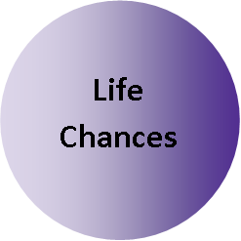

There are many aspects that comprise a good life. Some of these aspects we may value in common, for example, clean water, sunshine, love etcetera, while other aspects may be much more individual, like the sports team we choose to support. For each of us, how we define a good life is dependent upon various diverse aspects such as where we live, what we do, how we feel, what and who we know, what we eat, what we think, how we love, how we grow, how we belong, etcetera.
Achieving a good life is complex; a disruption, loss or gain in one part of our life can cause a ripple-effect disruption, loss or gain in other areas of our life. Part of the reason for this complexity is the necessary involvement of other people in our lives; it is hard to imagine a good life that doesn't have other people in it. This is because it is highly unlikely any one of us could meet all our personal needs and wants directly from our own skills and efforts. It is a rare person who has the extraordinary range of capacity, and time, to undertake their own dental work, maintain a market garden, construct a house, make steel, grow cotton for clothing, build a laptop and so on.

In this sense we all have a significant degree of vulnerability, and we manage this vulnerability by living a life characterised by interdependence, where we interact with other people in our world to fulfill a broad array of needs and preferences, ranging from fresh vegetables to primary healthcare, from artistic expression to unblocking drains, from borrowing the mower to minding the kids. From such interactions, a layered tapestry of valued relationships emerges and this is one of the hallmarks of a truly rich and good life.
This broad range of give-and-take relationships, characterised by interactions with people in varied “giving” and “receiving” roles is essential to the experience of Citizenhood. However, depending on personal circumstances, a person might struggle to move into, or remain in, habits of Citizenhood. This could happen to any person at any time but people may be particularly susceptible to this because of a perceived disadvantage such as a physical or intellectual impairment, or a lifestyle characterised by a relative poverty of resources and opportunities.

A good life is dependent upon various diverse aspects such as where we live, what we do, how we feel, what and who we know, what we eat, what we think, how we love, how we grow, how we belong

The Model of Citizenhood Support is a framework for determining what kind of assistance might be most helpful to people in such circumstances. However, it can also be used by anyone wishing to explore options to advance towards a good life. The Model carries the assumption that a good life is crafted by the decisions we make and the actions we take. However, our decisions and actions are facilitated or constrained by our life chances.
Having good life chances makes it easier for us to build a good life (though it’s no guarantee because we don’t always make the best decision or choose the best action). Having fewer life chances makes it harder for people to build the life they want.
The Model of Citizenhood Support asserts that our life chances comprise four different, but interrelated, types of assets we can call upon, termed the Four Capitals.

Introducing the Four Capitals

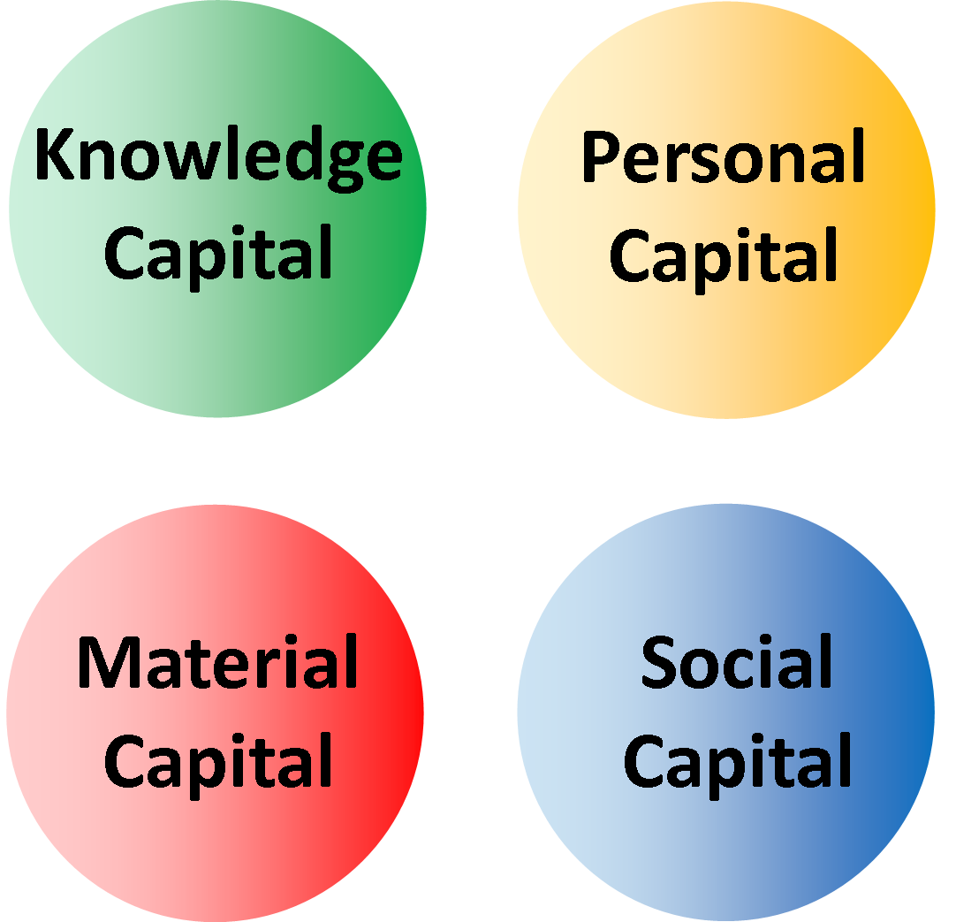

Having spent a number of years involved with systems of personal support for people in a number of jurisdictions, I have found the relative success or failure of such systems in advancing people’s life chances can be linked to the degree of attention given to four main elements. I have termed these elements Capitals, as follows:
  - Personal Capital (perspective)
  - Knowledge Capital (information and skills)
  - Material Capital (tangible physical resource)
  - Social Capital (connectivity with other people)
People seem to have enjoyed greater success in terms of wellbeing and Citizenhood when there has been decisive action in one or more of these four areas.
This model examines the characteristics of these Capitals. They represent people’s life chances and in each case this model explores what creates distance between the person and their life chances, and how that person might be assisted to access and build each Capital.

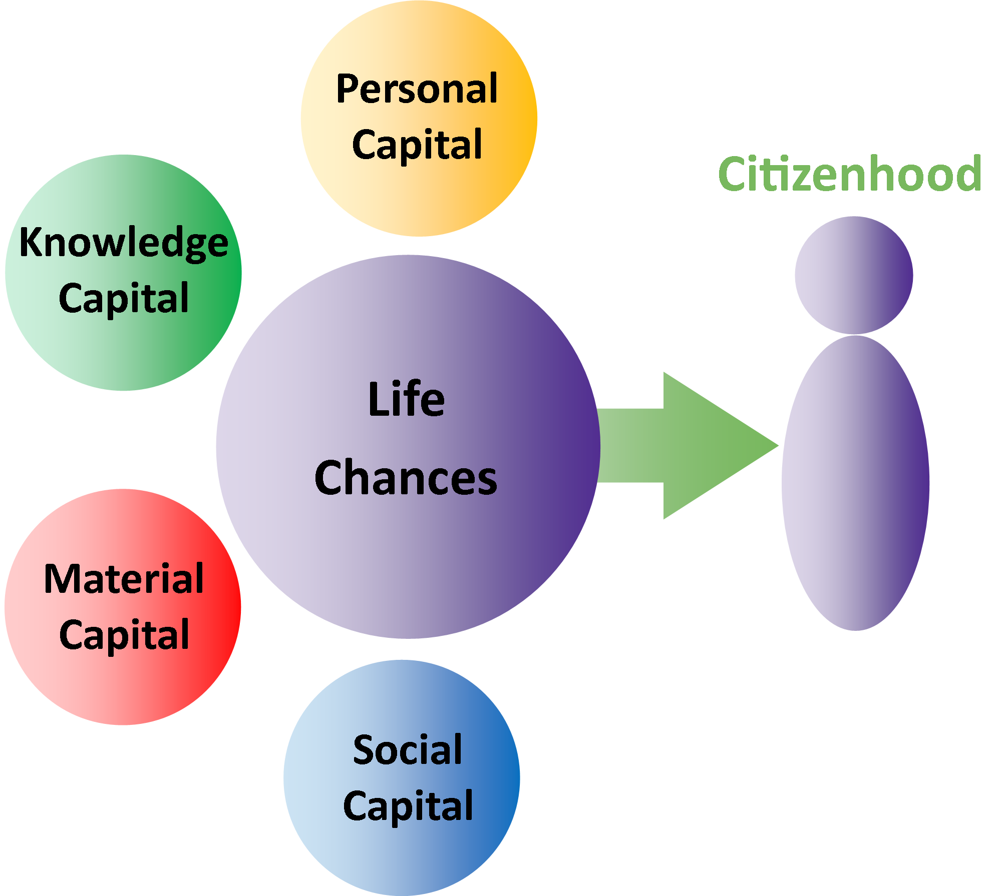

Capital is an interesting word because it usually appears in an economic context to describe material wealth that can be used to generate more material wealth. Accordingly we see the word used in phrases such as “capital investment” and “capital gains”. However there is merit in using the word more broadly, where capital is an asset or resource which may be used to a person's advantage. This is the definition of Capital chosen for this model. It brings a focus on any assets or resources which might be made available to a person to assist them to move into a life of active Citizenhood.

The Four Capitals are different but interrelated types of assets we can call upon

In considering the circumstances of people living with increased vulnerability, the Model of Citizenhood Support asserts the person might best be assisted to move into a life of active Citizenhood if there is an active focus on each of the Four Capitals to the degree that’s right for the person's situation.
The Model provides an opportunity for the person to reflect on how they are currently being supported and provides a similar opportunity for agencies or individuals (for example family or friends) to reflect on how they offer assistance to the person. Such reflection is important because the Model asserts decisions and actions taken by such agencies and agents will either grow Capital or diminish it; there is no decision or action that has a neutral effect on the Capitals. This is a critical point, because it illustrates the possibility that agencies or individuals involved in people’s lives may be making decisions or taking actions, however well-intentioned, that are diminishing the Capital available to the person. This is deeply counterproductive; why would we undertake practices, in the name of help, that diminish the Capital available to people already living lives of greater vulnerability?

Why would we undertake practices, in the name of help, that diminish the Capital available to people already living lives of greater vulnerability?

In addition to the Four Capitals there is a fifth consideration when formal agencies (or informal agents such as family and friends) take up particular roles in the lives of people living with greater vulnerability. This relates to the relationship the agency or agent has with the person. The model asserts the nature of this relationship, in particular the agency or agent’s approach to that relationship, can have a critical impact on all Four Capitals. This gives rise to the notion of an Authentically Helpful Relationship.

Of course, there are many people who do not have formal agencies actively involved in their lives, nor specific family or friends who are providing practical assistance with their daily living. However, the Model of Citizenhood Support remains just as relevant, providing an opportunity for a person to reflect on their current situation and consider the extent to which their own decisions and actions are growing or diminishing their Capital. This model has relevance to every person; it is an opportunity to reflect on the degree to which we are achieving authentic Citizenhood in our lives, and the extent of our Capital in support of that.
This monograph will now examine each of the Four Capitals in greater detail.

Personal Capital
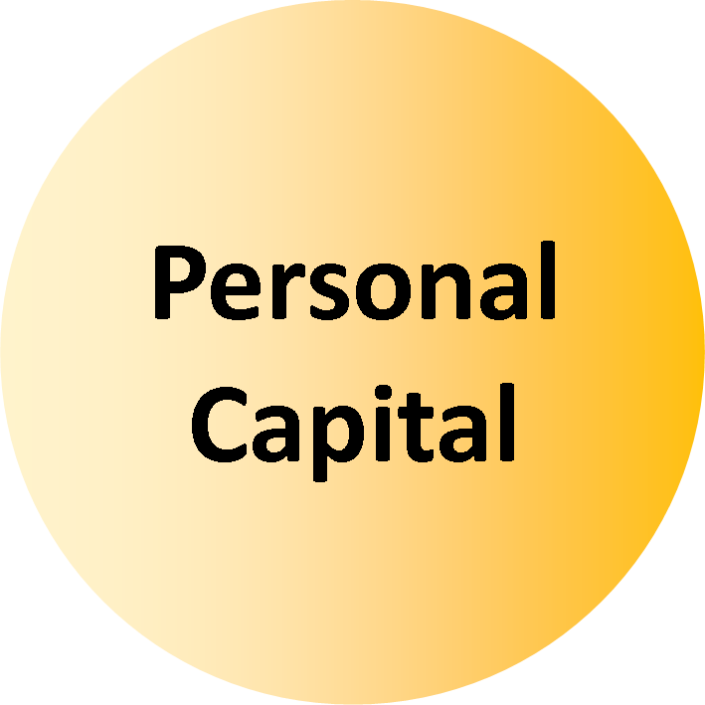

The Elements of Personal Capital
For a person to advance their chances of living a good life it is important for them to have a sense of who they are, their worth, and the vision or dream they are moving towards. This includes six important elements.
First there is the notion of inherent potential, where the person can acknowledge the inherent lifelong potential they have as a human being. Second is the notion of strengths, where the person has an appreciation of their current strengths, their gifts, their positive characteristics. Third is the notion of self-worth, the extent to which a person holds themselves in essential good regard. This is an emotional connection with who we are and who we could be. If a person does not have a good regard for themselves it is likely to have a critical impact on the potential and personal strengths they see in themselves, the extent of possibilities they might imagine in their life and the quality of the decisions and actions they then choose. Fourth is a personal vision of a good life. This is about having a sense of the good things that might be possible. This does not have to be particularly detailed (although some people like to plan that way); instead it is about the person being able to imagine the possibility of what a good life might look like for them. Fifth is the notion of personal control, where the person has authentic control of the decisions and actions they make in their life. It is hard to be the author of your own life if you don’t have control over your decisions or freedom to act. Sixth is the notion of confidence, where the person has the courage to act.

These elements – potential, strengths, self-worth, vision, control and confidence – represent personal assets, Personal Capital, that we might draw upon to advance or uphold a good life, a life characterised by Citizenhood. Their presence is at its most critical when the person is making personal decisions, choices or taking actions, because these are the essential expressions of Personhood.

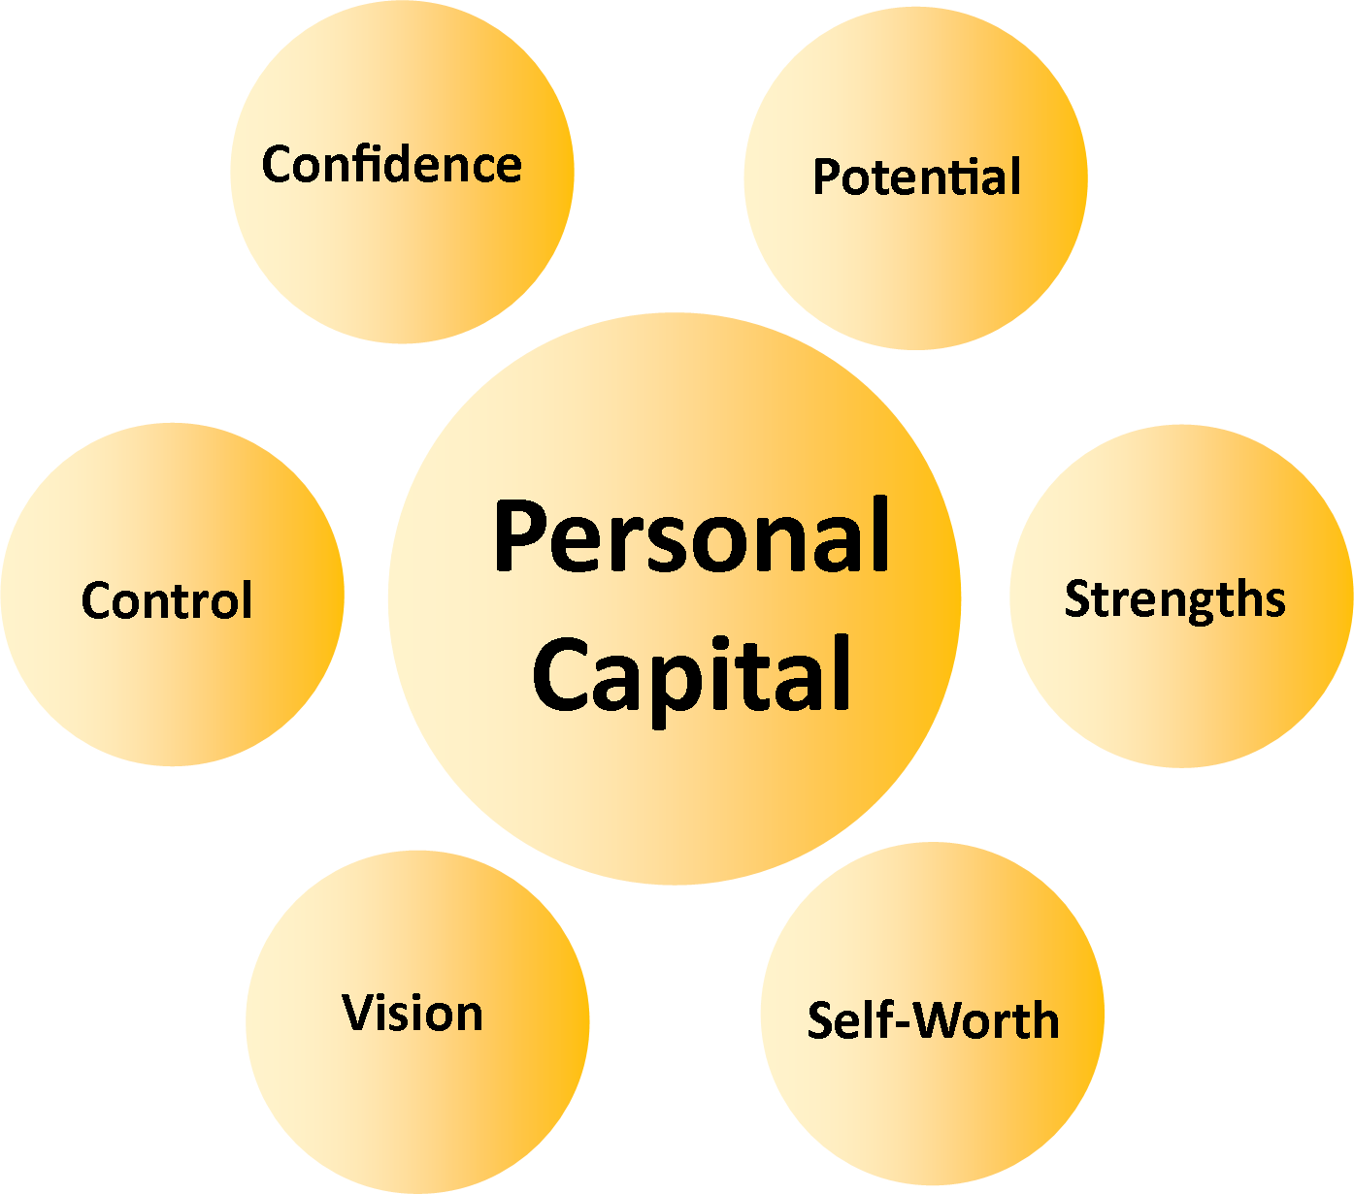

Distance from Personal Capital
People may vary in the degree to which they see the inherent worth in themselves, their capacity to take up a life of active Citizenhood, and what that might look like. The degree to which we give ourselves permission to do these things may depend on the life experiences we have had.

For example, imagine our life experience has included positive messages from others about our inherent worth. Imagine this has included the opportunity to have our potential and strengths acknowledged and appreciated, the opportunity to try new things, to take risks and to learn from the resulting experiences. Imagine we have been supported to see our valued place in the world, to dream what that might look like and to make decisions towards it. With such experience and support, we are perhaps more likely to have an appreciation of our potential, our capacity, our place in a good life, and the decisions and actions we can take in pursuit of it.
Unfortunately, the converse is also true. If our life experience has not included the opportunity to believe in our inherent potential and strengths, or the opportunity to imagine our valued place in the world, or the opportunity to make decisions and pursue experiences in support of this, then it is perhaps less likely that we will see the worth in ourselves and possibilities in our lives.
In our communities, some people are born into, or move into, circumstances where there is a greater struggle to achieve Citizenhood. People in such circumstances are more likely to come into contact with formal (or informal) welfare systems for income support, health assistance, daily living support, shelter, and so on (though even this is less likely if the person happens to live in a country without that infrastructure, or where the system has inadequacies that mean some people ‘fall through the gaps’).

Who you are, your worth, and the vision or dream you are moving towards

Unfortunately, for many people the experience of accessing such welfare has resulted in a diminished capacity to see their inherent worth, their strengths, and the possibility of a valued and fulfilling role in the world. This happens because the person is a passive recipient of welfare services; passive in the sense they are not an active partner in the decisions about how those services happen, and recipient in the sense that the person's role is to be the receiver of other people's efforts rather than the giver of their own.

Each time the person is a passive recipient of welfare services these messages are repeated and over time the person may come to believe the meaning of their life is to be passive and a recipient. When this happens, the person is in danger of losing sight of their potential, their strengths, the possibility of a good life, and their personal agency in making this happen. The horizon of what is possible shrinks down to a landscape of service recipiency.
This is ironic because we might suppose formal welfare is designed to advance and uphold a person's wellbeing as a citizen; yet it may be creating the opposite effect. It is therefore of critical importance we find ways to uphold and advance Personal Capital in people's lives. For each of us, the essence of Personal Capital is having a fundamental belief in ourselves; without this it becomes much harder to move into a good life. It follows that if a formal agency fails to properly attend to the issue of Personal Capital, its other well-intentioned efforts may not have the hoped-for impact.

Building Personal Capital – Statement of purpose for the helping agency/agent
Building Personal Capital is about building belief in ourselves – our potential, strengths, dreams of what might be possible in our lives, personal agency (the decisions and actions we take) and self-worth. Therefore it follows that if a formal agency is involved in our lives because of the increased vulnerability we live with, that agency should practice in ways which advance and uphold our Personal Capital.
In seeking to help a person, an agency (or individual agent) has a fundamental obligation to uphold that person’s Personal Capital. This means the agency must carry out its endeavours in ways that do not inadvertently (or intentionally) undermine the person’s view of their own potential, their strengths, their personal vision of what might be possible in their life, and their personal leadership as a decider and actor (i.e. the agency supports the person to make their own decisions and take their own actions, to express their Personhood).

As mentioned earlier, it may be possible that the person has low Personal Capital because their life experiences to date have resulted in a lower appreciation of their potential, their strengths, the possibility of the person expressing Personhood and Citizenhood. If so, the agency has a fundamental obligation to advance that person’s Personal Capital by taking deeply thoughtful and highly intentional steps to assist the person to connect with their potential, their strengths, a personal vision of a good life, and experience in making personal decisions and taking personal actions.

Upholding and Advancing Personal Capital – Considerations

Understanding the Person’s Story – The art of listening
For an agency to take deliberate steps to advance and uphold a person's Personal Capital, it must first develop a deeper understanding of the person, their life experience to date, and the effect of this on their Personal Capital.
To do this, an agency needs to reflect on how it comes to know the person. For example, an agency might use a particular assessment tool or other prescribed approach to discover a person's circumstances. Unfortunately, in applying such methodologies, particularly where there are time and resource constraints, the agency does not really get to know the person very well at all. Specific questions generate specific answers and often only derive sufficient information for the agency to calculate a measure of fit with the agency's offerings. Even though such approaches might be described as individualised planning, or even person-centred planning, they are in fact service-centred planning because the attempts to understand the person are framed in context of the agency's worldview, not the person's worldview.
The risk of service-centered planning exists for any agency that already has ideas in mind (or arrangements in place) for assisting people in similar situations. Even where such arrangements have previously proved helpful to people, the agency cannot wholly rely on the assumption such arrangements will have similar potency for the next person to come along with similar issues, otherwise this will close the agency's mind to the person’s personal circumstances and story, and to the full range of possibilities for upholding and advancing the person's life chances.

Therefore, the challenge for the service agency is to discover ways to get to know the person on the person's own terms. This may include placing a lesser reliance on formal tools and professional methodologies, and a greater reliance on the art of open-ended questioning and active listening.
This in turn presents challenges to the agency in terms of how it recruits, orientates and trains staff to develop the habits of heart, mind and practice most conducive to advancing and upholding Personal Capital.

Understanding the Effect of Services – The art of reflecting
By definition, people living with increased vulnerability may be more susceptible to unhelpful or unpleasant experiences at the hands of others. For an agency to be helpful it is important that it seeks to understand how a person's Personal Capital might have been diminished by their experience of services and supports. This can be particularly difficult as it implies a review of the agency's own efforts (or indeed the efforts of family members or friends actively involved in the life of the person).
This is a difficult journey because an agency might discover its own efforts have been counterproductive despite every good intention. Because of the possibility of this discovery the agency may struggle to truly reflect on its own practices, and perhaps even become defensive. This is not helpful. No agency can be expected to be perfect all the time. However, it is surely a reasonable expectation that an agency will reflect on its practice, identify those elements that are unhelpful, counterproductive, or even neglectful or abusive, and, by bringing those practices to a conscious level, resolve to eliminate them.
There are a number of ways an agency might undertake such reflection. Whichever approach is chosen, it is important that it is honest, transparent, comprehensive and auditable.

Responding to Personal Service Trauma – The art of healing
As each of us moves through life, there is the risk we will have experiences that are in some way psychologically or emotionally traumatising. For people and their families living with increased vulnerability such as disability, this risk includes the possible trauma from discovering or acquiring disability, or from other people’s expressed views of a person’s disability, or from the actions of others, or from the experience of service recipiency, or from the perception of lost or barred opportunity. Such trauma can stay with the person and with significant others such as family members, and have a profound impact on their Personal Capital.
Therefore it is important to develop a deeper understanding of the nature and extent of people’s traumatising experiences, and to understand what responses might help heal that trauma and rebuild Personal Capital. For example a person may have been a long-time service recipient in an agency that did not uphold each person's personal authority, instead expecting people to be compliant recipients of the services selected for them. This approach may have extended to the discouragement of complaints, and the disapproval, or even punishment, of those who do complain. In such settings it is not unusual for service recipients to learn that their voice is powerless, that it is not safe to complain, and therefore that one must be grateful for whatever service is available. Such learning represents the diminishment of Personal Capital.
Where a person has this history, it will be important for them, and therefore any agency or agent involved in supporting them, to find ways to unlearn these ideas and reclaim their voice and their right to good life chances. If the current agency was responsible for this history it will need to find ways to ensure the person knows how they can hold the agency accountable for this history, and how they can be assisted to initiate accountability.

Assisting a Person to Imagine What Might be Possible and Take Steps Towards It – The art of planning
Many service agencies will claim they undertake individual, person-centred planning to help figure out the supports a person might access and for what purpose. Typically this will involve an approved template, so that information may be gathered in a way that is familiar and easily used by the organisation.
As with the assessment tools described earlier in this chapter, a formula-based approach to individualised planning is fraught with difficulties because it can be skewed by the service agency’s own worldview. In short, the use of a standard template runs the risk of shoehorning a person's ideas for the sake of organisational convenience. The same risk exists for informal agents such as family or friends, whose own world view about what might be possible in the person’s life, might influence what is, and what isn’t, on the table when it comes to planning for the person’s future opportunities and supports.
A good plan is likely to be one that coherently fits with the issues and aspirations the person wants to work on and is set in the context of good life chances, and is anchored on the person's potential and strengths, and emphasises the person's central role in the decisions and actions arising from it.

Building a Life – The art of authoring
First and foremost, Personal Capital belongs to the person, and therefore the person takes the central role in upholding and advancing their own Personal Capital. In seeking to assist a person there is an ever-present risk that the agency (or informal agent) will assist the person to build Personal Capital in ways that reflect the agency’s world view rather than the world view of the person concerned. This risk needs to be addressed carefully; when all is said and done, most people want to author their own life, not have someone else author it for them.
This can be a complex issue. For example a person might have a very low horizon for what is possible in their life; a family member, friend or agency might hold a more affirming and expansive view of what might be possible in that person's life and seek to support a person to adopt this new horizon. Alternatively, a person might have a particularly grand view of what might be possible in their life, including goals that might appear unrealistic as they remain out of reach for most people in their lifetimes (such as becoming a country's president or landing on the moon); a family member, friend or agency might not wish to entertain and uphold such a view for fear this sets unrealistic expectations and will lead to abject disappointment or material calamity.

Finally, a person might have goals which are within reach of most people, but others in the person’s life may view such pursuits as unsafe or inappropriate because of the person’s circumstances. These types of situations can be difficult to navigate and there is a risk the person’s authorship might be overshadowed by the concerns of others. In such situations there is no routine recipe for success, nor should there be because each person deserves highly personalised enquiry.
However there are useful anchor points including:
- The assumption of potential, where the goal of Citizenhood is available to all people regardless of the precise form that it takes; despite personal circumstances each person has characteristics that are assets to the person and to the wider community
- The assumption of Personhood, where the person is front and centre to any decisions that affect them
- The assumption of risk, because it exists in all aspects of life, and the corresponding attention to safeguards, because their presence can help navigate risk and advance and uphold the person’s place in community life.
An approach that reflects such anchor points is Support Decision Making which aims to assist people to understand their choices and make decisions. For people living with increased vulnerability, especially in the area of decision-making, the approach can help a person retain authoring of their life. Even where a substitute decision-maker (for example a Guardian) has been appointed, the principles of the approach can help advance the person’s authorship.

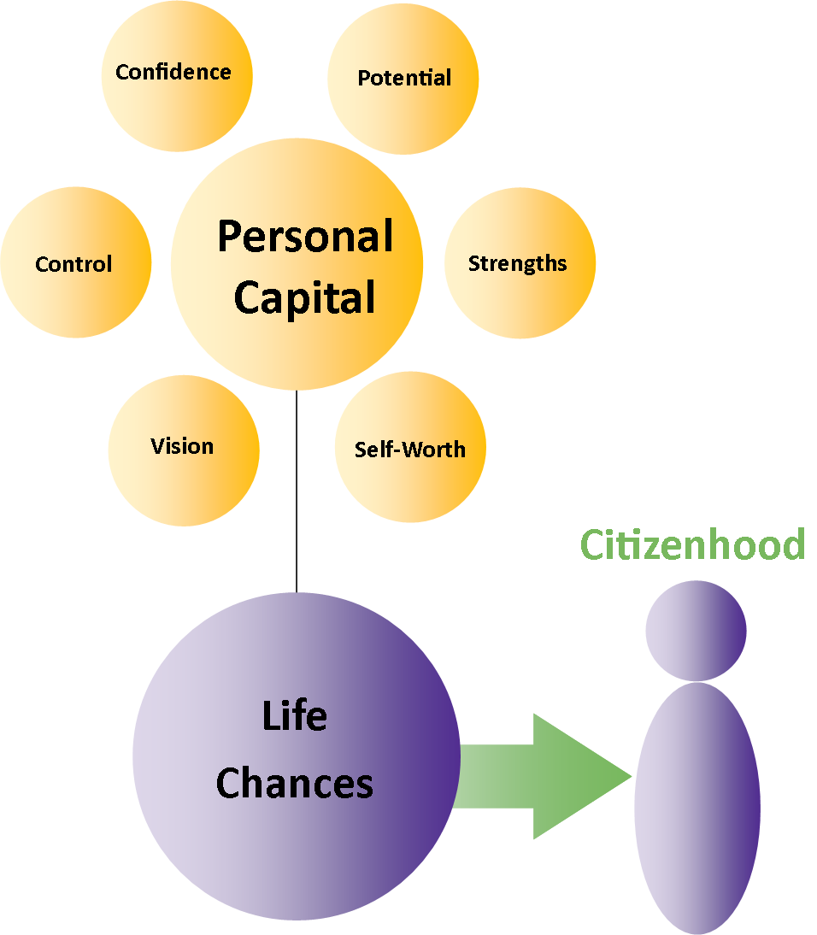

Knowledge Capital
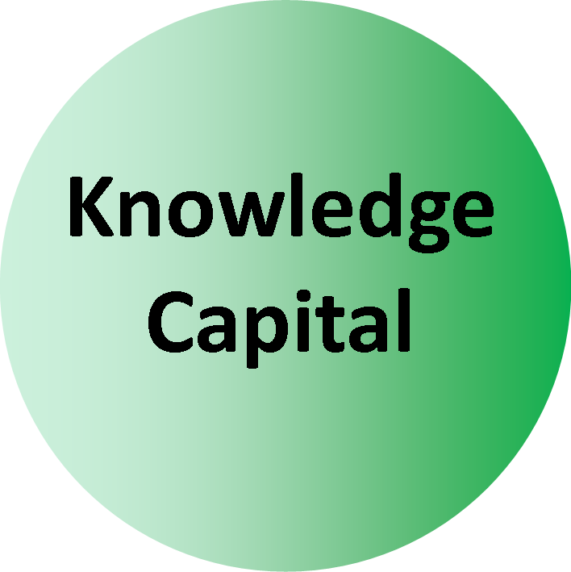

The Elements of Knowledge Capital
Information is critical in our lives. It helps us make choices about everything – where we live, the work we do, the food we eat, the places we visit, the friends we discover, the values we claim, the groups we join, the politicians we vote for and much more.
Information helps us understand and describe our potential. Information can grow our capacity because we can call on that information again and again. Information is critical to the exercise of personal agency; we use information to help us test ideas and assess risk. Good information helps us make informed choices and take informed actions.
In these ways we build a personal store of information, which we can use to support our decision-making and our action-taking. This personal information store is an asset; it is our Knowledge Capital. The development of Knowledge Capital, for example through education, training and career experience, and of course on the street of life, can be critical to our life chances. Knowledge Capital, and the way we use it, can improve our prospects for accessing a wide range of life opportunities such as new jobs, new acquaintances and a new perspective of ourselves. As such, Knowledge Capital has a fundamental interrelationship with the other Capitals in the Model.
In thinking about Knowledge Capital, there are two main considerations: first, how a person might make the best use of the knowledge, skill and information pathways they already have, and second, how a person might access more.
Given the importance of Knowledge Capital in our lives, it follows that its growth is a particularly important consideration for people living with increased vulnerability. Knowledge Capital is anchored on the availability of relevant meaningful information. In accessing meaningful and relevant information, there are at least two main challenges for people who live lives of increased vulnerability.

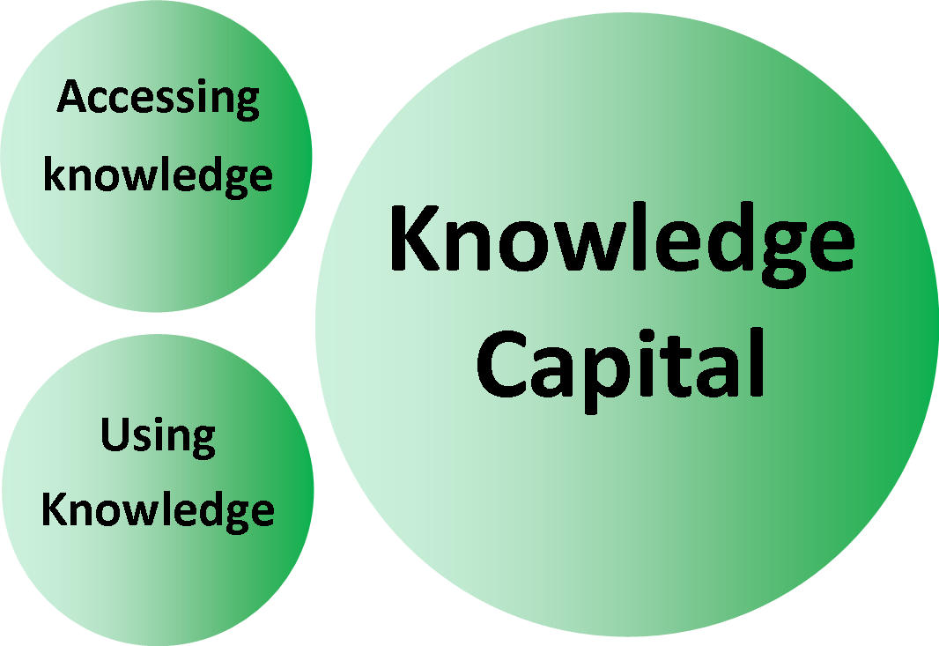

Distance from Knowledge Capital

The Issue of Access
Since at least the early 1990s we've been in the grip of an information revolution, so much so that some of the richest people in the world now are those who have pioneered methods and technologies for the generation, storage and access of information. In just a few short years we have seen a massive explosion in the availability of information and it is hard to imagine any aspect of lifestyle that doesn’t have an app to support it.
Herein lies the first challenge – how to physically access information. One of the main reasons for the enormous expansion of information has been the advancement of electronic technology. The advances in hardware, from mainframe to desktop to laptop to handheld, have been matched by similar advances in data coding, storage and retrieval, resulting in an almost unimaginable amount of information being available at the sweep of a fingertip.
Prices have fallen as these technologies have moved into the mainstream. However, currently there is still a cost involved. Given many people who live with greater vulnerability often also live on very low incomes, information technology can remain beyond their grasp. In turn this reduces the opportunity for people to build their Knowledge Capital, which in turn impacts on informed decision-making and action-taking.
This lost opportunity to build Knowledge Capital will remain as long as we have a situation where information comes at a price that people living on low income cannot afford. In addition to the barrier of poverty, depending on how it’s presented, information can also be rendered inaccessible to people with low or no vision, people who have limited physical movement, people with lower cognition or lower literacy skills, or people who use a different language.

The Issue of Filters
The second challenge is in understanding the extent of filtering of information before it reaches a person. It is important to know this so that one might assess the relative value of information. This is a challenge because all information is filtered. Journalists and editors decide what information they will publish in their print, television, radio and online media and how it will be presented. Biographers and historians decide which events and testimonies to focus on. Legislators and regulators determine the rules for how information might be presented and accessed. Scientists determine which lines of enquiry to pursue in the quest for new knowledge, and their efforts in turn are influenced by which lines of enquiry are commissioned by funders.
Individuals choose what information to put in their résumés and on their social media channels. To varying degrees, governments, businesses and individuals decide what information to share and how to share it. All of these are examples of filtering.
Therefore, if filtering cannot be avoided, it is important to understand as much as we can about what filters might have been applied to information we seek, as this will help us decide how meaningful, relevant and accurate the information is. It also helps reduce the chances that information is underrepresented, misrepresented or otherwise misaligned with the notion of a good life of active Citizenhood (at least, according to the filters I’m running as I write this).
One of the problems for a person living with greater vulnerability is they might have formal agencies in their lives (or informal agents) who are assuming roles as information providers and who, of course, cannot help but filter that information. The same piece of information will have different meaning and different relevance depending on the beholder’s worldview. For example, consider an agency runs supported accommodation through a cluster housing model. This aggregate model requires an aggregate budget typically funded by the government through a small block contract. The underlying assumption is that if a person lives with a particular set of disabling circumstances, the only way they can get the basic support they need is by accessing support in a shared setting.

Information is critical to the exercise of personal agency; we use information to help us test ideas and assess risk

Continuing with this example, let us now imagine the government funder introduces a new opportunity where a person can have a personalised budget to choose the services they want. It is entirely possible that the service agency finds itself in a situation where it has to explain this opportunity to each person in their cluster housing. The problem for the service agency is that if one or more people then choose to take that personalised budget and use it for a different service, the cluster housing support service will no longer be viable because it relies on full occupancy.
Issues of sustainability have been and always will be a concern for service agencies. There is a risk this will impact on the way the agency filters information about personalised budgets. This is not to suggest the agency is seeking to intentionally harm a person's prospects; it simply reflects the distinct likelihood that anxiety about agency sustainability might intrude on the way the agency shares information with each person. The consequence might be the information is shared in a way that understates its meaning and relevance to the person’s situation; this reduces the potency of the information to assist the person to make an informed choice.

Such dilemmas not only occur in the province of service agencies. For example a family's concerns about personal risk might influence the way they pass information to a loved one on matters such as leaving home, seeking relationships, and aspiring to parenthood. Whatever the issue, there is always the possibility that information will be filtered in a way which compromises its meaning and relevance. It is not easy to prescribe how this should be resolved, or indeed to determine if it ever can be fully resolved. After all, none of us is perfect, and it is likely that in our past we have made some decisions, and taken some actions, that turned out poorly for us, sometimes because we took people's advice and sometimes because we didn't.

Building Knowledge Capital – Statement of purpose
Building Knowledge Capital is about building our capacity to access, understand and apply information that can help advance us into a good life, a valued life of active Citizenhood.
Therefore it follows that if we have family, friends or a formal agency involved in key aspects of our lives, because of the increased vulnerability we live with, their assistance should take place in ways which advance and uphold our Knowledge Capital.
In our daily lives there is a myriad of opportunities to access helpful information and grow knowledge capital. This includes static information-gathering pathways (such as reading, browsing the internet, watching, listening) and also dynamic pathways such as the potency of personal experience (trying out new things for ourselves).
In seeking to help a person, an agency (or individual agent) has a fundamental obligation to uphold that person’s Knowledge Capital, and to build on it. This means the agency must carry out its endeavours in ways which do not inadvertently undermine the person’s access, understanding, and use of their Knowledge Capital. This includes the need to avoid unhelpful practices such as being dismissive or critical of information the person finds highly meaningful, and practices which compromise the person’s access to their Knowledge Capital (such as not assisting the person to access their personal information via an Internet-enabled laptop or tablet or smartphone, or their public information technology, like the local library).

In addition, it may be possible that a person has poor Knowledge Capital, including a low appreciation of the place of information in our lives and the possibility there may be information within reach that proves deeply meaningful. This includes information that could grow a person’s view of their own potential, their strengths, and the possibility of an ordinary valued life. Sometimes this information comes from the stories of others on the same road in life.
If this is so, the agency (or family or friend similarly involved in the person's life) has a fundamental obligation to advance that person’s Knowledge Capital by taking deeply thoughtful and highly intentional steps to assist the person to access information that may eventually prove meaningful, especially in the context of advancing the person’s life chances.

Upholding and Advancing Knowledge Capital
In the first edition of this Model of Citizenhood Support, we asserted the notion of Supported Information, which referred to “resourcing of information so that it is accessible and understandable, and soundly relates to the person's best interests”.
The notion of best interests is a critical issue in upholding and advancing Knowledge Capital. Just because a person lives with increased vulnerability does not necessarily mean they lack clarity about what they consider to be their best interests. In this situation, the formal agency (or family or friend actively involved in supporting the person's daily life) is most likely to be helpful by working with the person to identify how best to support their access to information.
There are a range of practicalities associated with this. The agency will need to think through how it makes information available, so that the information is neither hidden from view nor rendered inaccessible. There are well-established methods for auditing the availability and accessibility of information, and it is worthwhile for an agency to undertake an information audit on a regular basis. This will help ensure the agency is aware of, and addressing, any issues blocking access to helpful information. Interestingly, there may be some tension between the declared best interests of the individual and the separately perceived best interests of the agency. Because of this, an information audit needs to be a deeply thoughtful endeavour to ensure the agency is able to address any instances where information practices may prioritise the agency's own interests over the interests of the people it claims to serve. Essentially, this is about the agency having a habit of openness, together with an appreciation of the importance of Knowledge Capital to a person's life chances.
For a person who lives with greater vulnerability, particularly where this adversely affects their capacity to assess their options and make decisions, a good starting point for considering what and how information is made available is to return to the person's Personal Capital. This would involve reconnecting with the principle of the person's lifelong potential, deepening an understanding of the person’s quest for a good life, and having regard for the person’s strengths. This can help give context for how and what information is made available.
This may be challenging if a person has very low Personal Capital. If so, the agency needs to make a sustained effort to help the person access helpful and meaningful information which may help them develop a deeper appreciation of life's possibilities.
This effort is not limited to how an agency might help a person access the spoken or written word or pictures. Information also comes from personal experience; the agency's efforts need to include supporting the person to access opportunities that can bring new information, new learning and new skills. Such opportunities need to be crafted in the context of a valued life of active Citizenhood.
Note the role of a formal agency is not necessarily to always directly deliver information itself; it is possible the agency might instead facilitate access to those who possess helpful and meaningful information. For example, this might involve the agency assisting a person to connect with other people who have been in a similar situation and whose stories might yield highly meaningful information.
This might then contribute to the advancement of the person’s Knowledge Capital about what is possible in people's lives, which in turn contributes to the advancement of the person’s Personal Capital about what is possible in their own life.

Finally, it is worth noting that information is a two-way street. Just as an individual person has Knowledge Capital, so too does an agency have Knowledge Capital. By truly listening to the experiences, concerns and aspirations of the people served (and of people with comparable experiences), the agency is accessing helpful information to grow its own Knowledge Capital. The agency can then call on this asset to guide its own decision-making and action-taking. Given the richness of such material and its typically strong relevance to the stated objects of the formal agency, it makes sense for the agency to strengthen the ways it facilitates, and listens to, feedback from the people it seeks to serve. It seems deeply counterintuitive and counterproductive to ignore the importance of such channels, even if such channels include complaints which the agency finds difficult to hear.

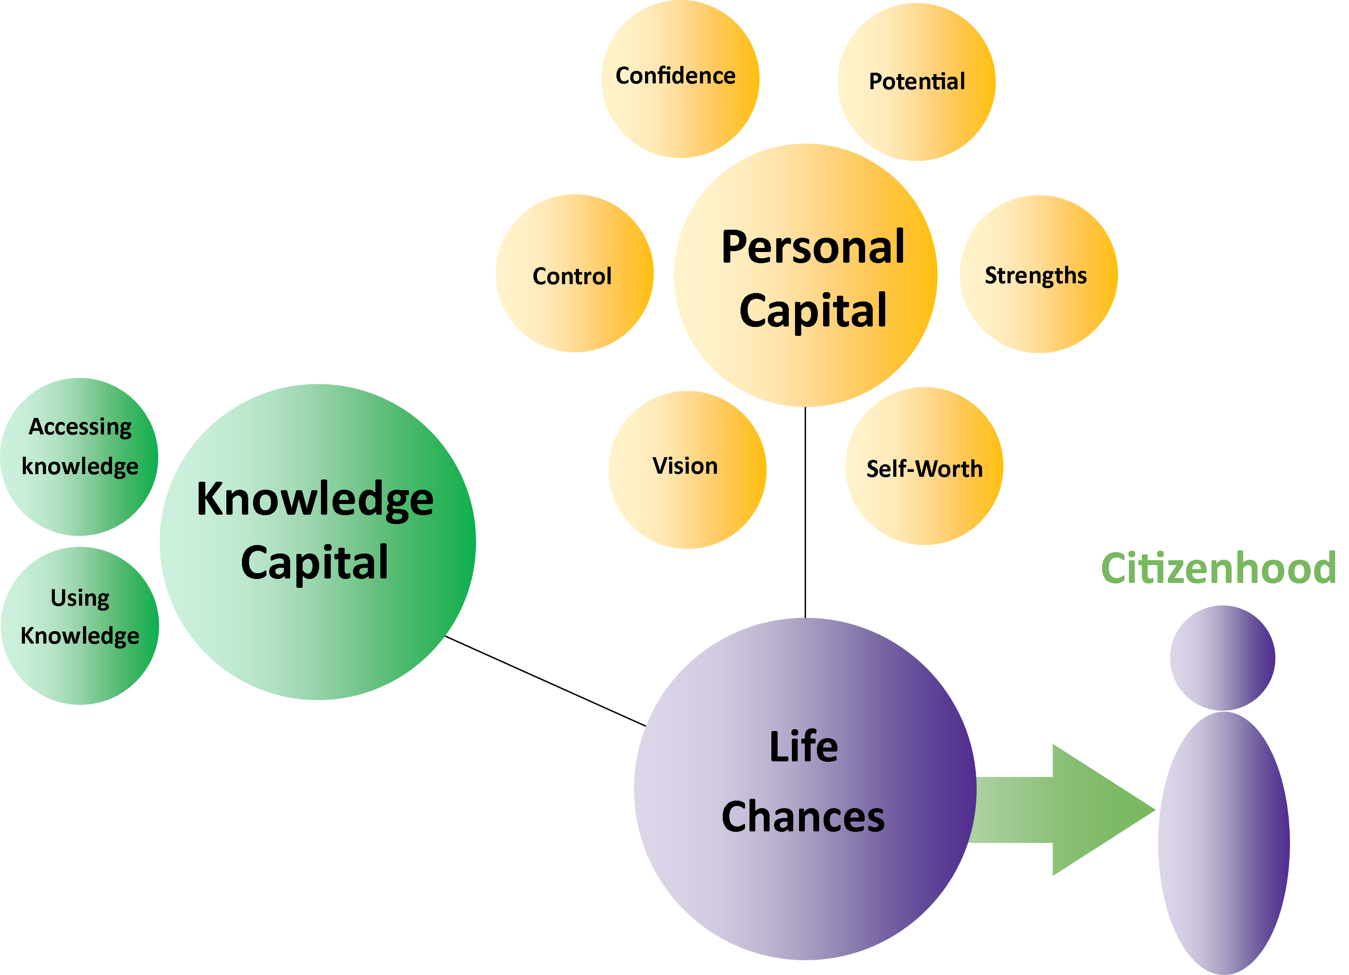

Material Capital
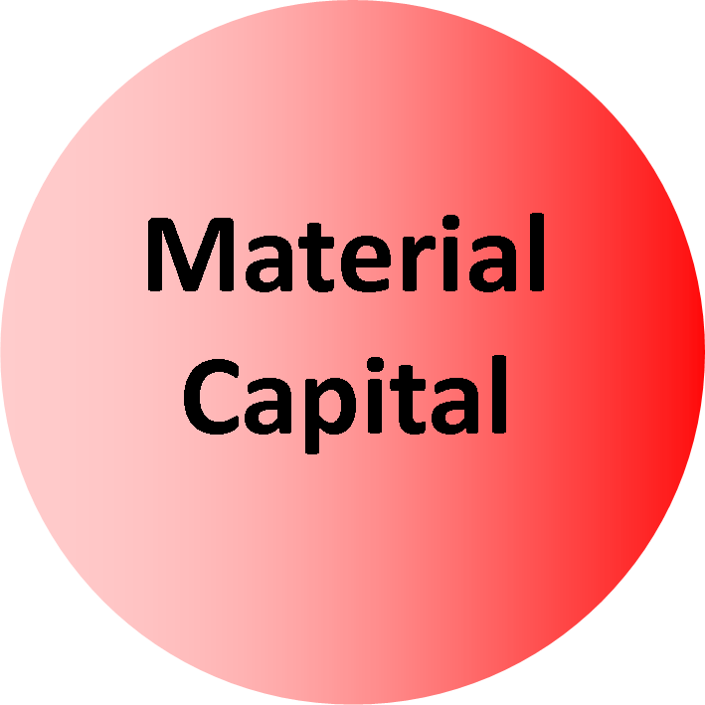

The Elements of Material Capital
Of the four types of Capital described in the Model, Material Capital Is the one most similar to the conventional understanding of the word “Capital”. Material Capital refers to items in our lives which are tangible, concrete and have extrinsic material value. In conventional economics this includes cash, property and other items of cash value, for example company shares. Such items are included in the concept of Material Capital in this Model, but the notion of Material Capital includes a far broader range of elements, organised into two main categories.

Material Capital includes items in our lives which are tangible, concrete and have extrinsic material value
The Model of Citizenhood Support asserts two main types of Material Capital – Personal Material Capital and Public Material Capital. Both need to be actively addressed if we are to advance a person’s life chances towards a good life, a valued life of active Citizenhood.

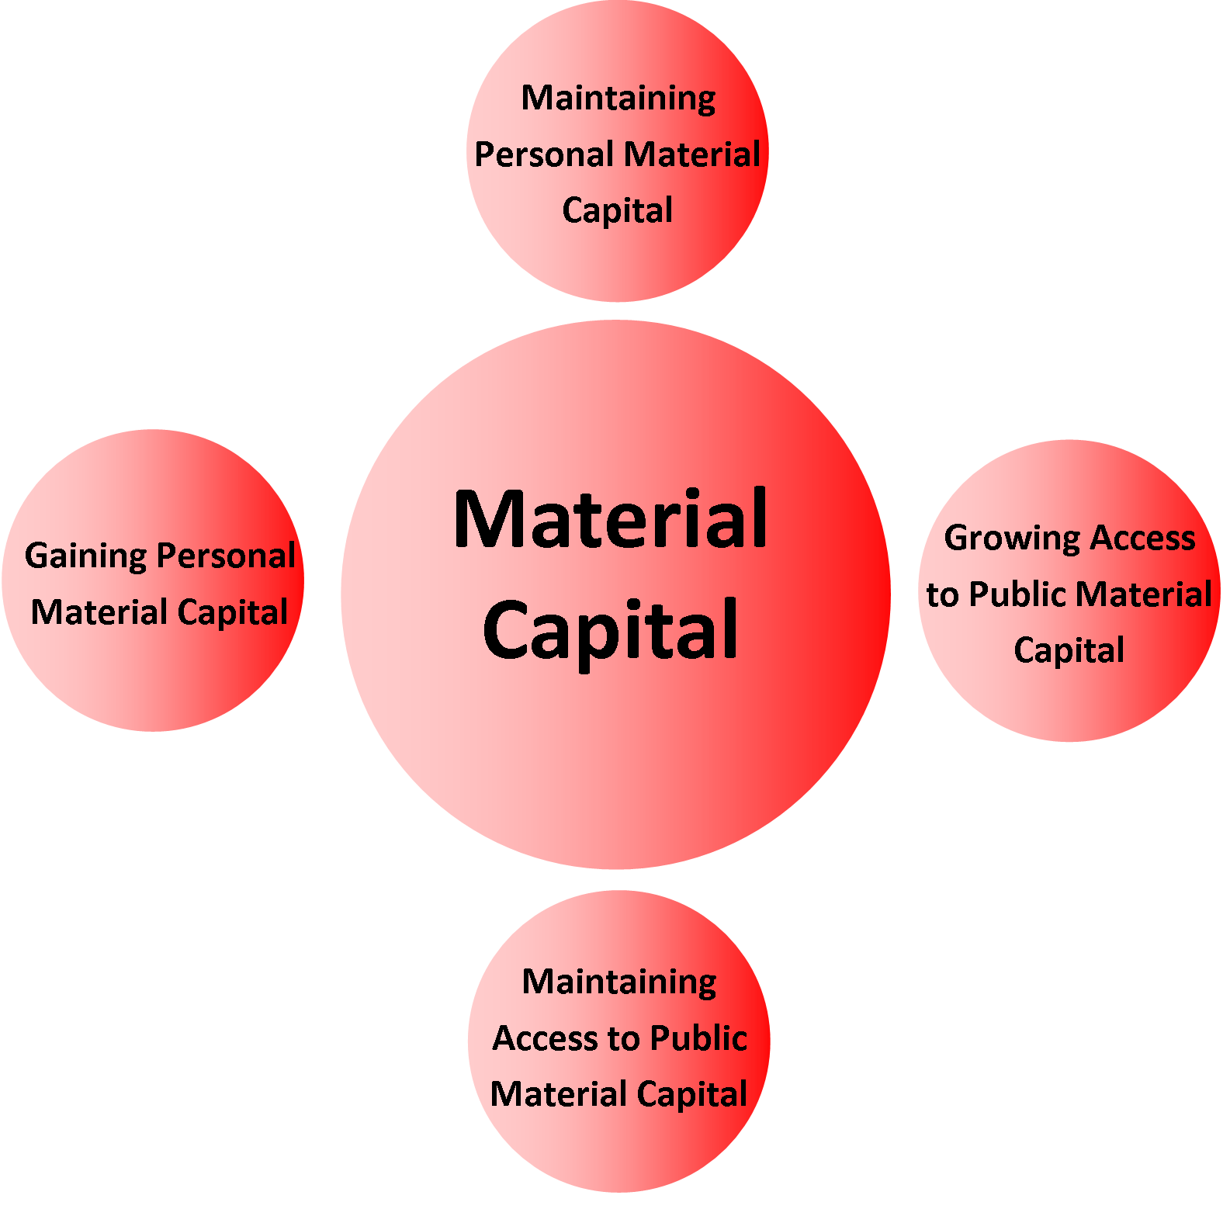

Personal Material Capital
Personal Material Capital refers to tangible assets owned or controlled by the person themselves. Such assets might include money, for example income or savings, and property, for example housing, vehicles, and various personal effects including durables like furniture and consumables like groceries.
There is no doubt that the presence of personal material capital can have a very positive impact on a person's life chances; housing and personal effects deliver practical benefits including the inference of social standing. Money, a pivotal material asset, brings more choices.

Personal Material Capital carries great significance in our society and this is reflected in the constant bombardment of messages, through advertising, presenting a vision of a good life through the accumulation of material wealth. Regardless of the extent to which a person might subscribe to such a vision, the fact is many of the transactions of active Citizenhood rely to a greater or lesser extent on the availability of Personal Material Capital.
Note that Personal Material Capital includes tangible items owned by the person, but also includes tangible items which may not be owned by the person but for which the person has control for the duration of their access to the item. An example of this is rental accommodation. The person is not necessarily the owner of the accommodation, but as the tenant the person has a critical level of control over that asset for the duration of the lease.
Note also that Personal Material Capital includes a job which pays a living wage. As such, the Model of Citizenhood Support identifies paid work as a tangible material asset because it delivers a regular income.

Public Material Capital
Public Material Capital refers to the tangible assets within our communities, be they publicly or privately owned, available for the broader population to use. Such tangible assets include public transportation, libraries, community centres, open spaces, stores, shopping malls, hotels, telecommunications and utilities networks, government buildings, sport and recreation venues, the beach, and so on.
Though an individual person does not have personal ownership or control over such assets, the person can utilise these assets as part of daily living. Indeed, access to such assets is instrumental to a life of active Citizenhood. Because public material assets are made available to people in common, at least on the basis of paying the price of admission, or having met other certain conditions, the shared use of such assets typically becomes the platform for people to connect with each other.

Distance from Material Capital

Distance from Personal Material Capital
Given the value our society places on Personal Material Capital, it is much more difficult to advance into a life of active Citizenhood from a position of low Personal Material Capital, otherwise known as poverty. The experience of poverty is driven by very low income, which typically translates to poor or no housing, difficulties with costs of food and utilities, and less involvement in community life because of the difficulties meeting the costs of public transportation, public entertainment, and so on. The experience of poverty dramatically reduces the range of choices available to the person, because many choices in life are dependent on people having money. Fewer choices mean fewer opportunities, and fewer opportunities means less active Citizenhood.
This becomes a vicious cycle. If we have fewer opportunities for active Citizenhood, this diminishes our Social Capital (through social isolation and loneliness), our Knowledge Capital (because it is much harder to learn and grow in the absence of new experiences, some of which have a price of admission) and our Personal Capital (through a diminished view of our personal worth).
Australia and other jurisdictions regularly produce statistics which show people living with greater vulnerability, such as significant disability, are more likely to be living in poverty, or at risk of it. Given the impact poverty has on people’s life chances, this is a serious issue, and raises questions about the way public funds are used to assist people living in poverty. This question is about whether the centre of gravity of such public funding is “on the front foot”, finding ways to advance people from poverty, or whether it is on the “back foot”, attempting to alleviate the darkest elements of crisis but ultimately keeping people in poverty.

Distance from Public Material Capital
As outlined above, the experience of poverty means people cannot afford to access material amenities in the wider community. In this way, low Personal Material Capital makes it harder for a person to access Public Material Capital. It’s harder to get to the beach, or the library, or the premises of a potential employer, if you can’t afford the bus fare to get there.
In addition, some people may experience specific difficulties accessing Public Material Capital even if they do not live in poverty. For example, if a bus, train or taxi is not accessible to a customer using a wheelchair, this diminishes the person’s Material Capital; the person is not able to use that transport, which in turn affects what the person was hoping to do once the journey was completed. While various jurisdictions are making efforts to improve accessibility across a range of community amenities like transportation and buildings, this remains a serious issue. If in its design the bulk of Public Material Capital is inaccessible to sections of the citizenry, many of those people will be less able to engage in community life on the same basis as others, and this cuts people off from an almost incalculable range of possibilities – for growth, for work, for love, for belonging.

The Notion of the Common Good
In our communities nobody is truly independent. Even a very wealthy person still relies on other people making a contribution to their wellbeing, whether it is the availability of a garbage collector, smartphone manufacturer or heart surgeon. We all live with interdependence, a mutual reliance on each other. This helps explain why we organise ourselves into communities where, in the name of mutual benefit, we undertake transactions, build resources, and forge relationships.
In such communities of interest, members often agree to make personal contributions in support of the common interest. The nature of contributions can vary. For example, it might be people's time, such as “working bees” where community members assemble together to undertake work for the benefit of their community. Alternatively the nature of contribution might be people's money, such as members of a sports club paying annual subscription fees so the club and its amenities remain available for the benefit of the members. Such is the nature of a “community of interest”.
A country is a particularly large example of a community of interest. Within a country there are many ways citizens can make personal contributions of their own time, for example through volunteering. Apart from those rare occasions where there might be a coordinated national voluntary effort, for example at times of national crisis, voluntary effort tends to be focused at a local level. Instead, the main way a country acquires resource for the community of interest is through the generation of public funds.
In the main, public funds are created through taxation, and these funds are used by the government of the day to bring benefits to our communities and the people therein. Essentially this principle can be described as the Common Good. Each citizen is expected to make a material contribution to the Common Good according to their personal means.
When governments spend public funds on advancing the Common Good, the expenditure tends to be on building Material Capital. Governments seek to build Public Material Capital (for the Common Good) by spending money on roads, bridges, railways, public transportation, electricity, water, rubbish collection, street lighting, sewerage, schools, hospitals, libraries and so on. Improvements in these areas bring greater convenience and opportunity for people; in turn this brings the possibility of people making a greater contribution personally and through taxation, which in turn generates more resource to spend on the Common Good.
For similar reasons, governments also spend money to help advance Personal Material Capital. Such expenditure includes items like income support payments to people not in work, and social housing so that people have a place to call home. One might imagine the government hopes such expenditure advances people's life chances. After all, this is the Common Good; people make contributions to the Common Good during the good times, and then draw on the Common Good during the difficult times.
Unfortunately, some members of our community remain locked in dependence on the Common Good and have little or no opportunity to make contribution to the Common Good (typically this includes people living with increased vulnerability due to disability, age, health or other circumstances of disadvantage). If so, it suggests our public expenditure is not as effective as it could be in generating Material Capital which can improve people's life chances. This is an important issue; given the highly vulnerable circumstances that many people find themselves in, we cannot afford to maintain patterns of public expenditure that do not advance people's life chances.

Building Material Capital – Statement of Purpose
Building Material Capital is about growing the range of personal material resources under the ownership or control of the person, and building the person’s use of typical public material resources, to help advance a person’s chances of a good life, a valued life of active Citizenhood.
These are considerations for every one of us, regardless of the degree of vulnerability in our lives. It also follows that if we have family, friends or a formal agency involved in key aspects of our lives because of our increased vulnerability, that assistance should take place in ways which advance and uphold our Material Capital.
People need to be able to access Material Capital in support of active Citizenhood. This includes maintaining (upholding) current Material Capital and also growing (advancing) Material Capital.
If a person needs assistance because of increased vulnerability, the formal agency (or individual agent) has a fundamental obligation to uphold that person’s Material Capital. This means the agency must carry out its endeavours in ways which help maintain, and do not inadvertently undermine, the person’s ownership or control of personal material resources, or the person’s access to publicly available amenities.
Similarly, the agency or agent formally involved in the life of a person living with increased vulnerability can also play a key role in supporting the person to advance Material Capital.

Upholding and Advancing Material Capital – Considerations

Upholding Personal Material Capital – Respect and Care
In general, we each have some measure of appreciation of the value of assets under our personal control. In line with this, we try to take care of our things the best we can so that they remain available to us. For example, we might attempt to operate our DVD player according to instructions, mow our lawns, and call the plumber when we need, or try to take care of our bodies.
Where people live with increased vulnerability, it becomes more likely that assistance is needed with these matters. This assistance can come from a formal agency, and/or from family or friends. It is important that such assistance is rendered in a way that carries respect for the person’s belongings. While the deliberate abuse and neglect of a person's belongings (including their person) are obvious grounds for outrage and immediate restoration, there are other more subtle practices, however well-intentioned, which need to be avoided.
This could include using that person's belongings in ways which make them less available. This can happen in supported accommodation, for example when a support agency “takes over” the person’s spare bedroom as an office or staff rest area. When this happens the person no longer has the use of the asset to advance other aspects of their life, such as having a friend come to stay. The agency may not have intended to diminish the person’s Personal Material Capital, nevertheless that is the consequence.
Similarly an agency staff member might place some of the person’s personal possessions on a shelf which is too high for the person to reach because they use a wheelchair. Even though the person still owns these items, the person no longer has control over access to them. In this way the person’s Personal Material Capital has been diminished.
In addition to having control over the place we call home, the most important element of Personal Material Capital for most of us is a job paying an authentic living wage. In which case, it is of critical importance the people providing practical assistance to a person living with greater vulnerability accomplish this in a way which strengthens the likelihood of the person gaining, and remaining in, paid employment.

Upholding Access to Public Material Capital – Avoiding the Creation of “Special”
An agency or agent also needs to avoid practices which diminish a person’s access to mainstream Public Material Capital. Remembering the use of Public Material Capital can help advance our life chances, it is important the agency or agent assists the person to take advantage of this available capital. Unfortunately, and often with the best of intentions, agencies can put arrangements in place which diminish a person's access to Public Material Capital. For example, an agency might invest in a special minibus dedicated for use by persons living with disability. This is well-intentioned, but it can be problematic, because it may make it less likely the person is supported to use available accessible public transportation, or take a ride from friends or neighbours. A further problem is the use of the agency’s special minibus means its passengers are less visible to the wider community, because non-disabled people aren’t using the same transportation because it isn’t public transport. This in turn may lead members of the wider community to assume some public amenities are not for some types of people who have their own special arrangements.
This can also happen in schools, where some students living with significant disability might be separately channeled to a special education program in a special education facility.
The above points are not intended to condemn all attempts at putting special arrangements in place to support people living with specific types of increased vulnerability, but to illustrate the possible impact on both the person’s access to Public Material Capital and the wider community’s assumptions about who can access what.

Advancing Personal Material Capital – Finding Meaningful Paid Work
Earning a living wage is the primary way most people maintain and grow their Material Capital; therefore meaningful paid employment is a powerful way to advance a person into a life of active Citizenhood. This steady income means the person can pay for things they might need, build savings, purchase material possessions which have meaning and utility, pay for access to public amenities like public transportation and entertainment venues, buy access to further education and training, take vacations, perhaps own their own home and, of course, contribute to the Common Good through tax payments.
The Australian Bureau of Statistics summarises the importance of employment to life chances, in a phrase that matches well with the four Capitals in the Model.
Employment can provide financial independence, a better standard of living and improved physical and mental health. Entering employment can provide individuals with increased confidence, expanding their social network and social skills as well as opportunities to develop a career by gaining new work skills and knowledge (Australian Bureau of Statistics 2012)
For a person of working age living with increased vulnerability, the question is what support arrangements might best assist that person to access authentic waged employment.
For example, people living with disability currently have lower participation rates in the Australian labour market. Alternative arrangements include ‘work preparation’ programs, participation in ‘supported employment’ disability enterprises, and volunteer work. In addition to giving people a pathway into paid employment, these opportunities are said to bring other benefits such as social belonging, new skills, meaningful contribution, safety assurance for families, and perhaps even respite from a harsh world.
It is not my intention to debate the merits of such endeavours here. However, the common issue they have is they are not able to offer an authentic living wage.
Therefore, given the importance of a living wage to a person’s life chances, the challenge for agencies is how to maintain a strong focus on assisting people into authentic employment paying a living wage, and to firmly resist the temptation to conclude such a goal might not be possible for people with certain types of vulnerability.

Advancing Personal Material Capital – Creating Personalised Budgets
As mentioned earlier, part of our taxation payments for the Common Good are spent on providing assistance to people who live with increased vulnerability. Over and above payments in response to poverty, public funding is made available so people can access practical assistance with daily living. Often this is arranged through block contracts where the government pays an agency to provide a block of service to a block of people in a block price. Sometimes such funding might be attached to individuals but often this is in name only as the individual amounts are grouped together in order to provide the service to the group. Such tangible resources, in the delivery of practical assistance, directly relate to the idea of Personal Material Capital. However these material resources are not really under the control of the individual person, who instead is a somewhat passive recipient with limited choice.

In response to this problem we have seen the emergence of alternative methods of funding which focus on the individual. In particular the theory and practice of Individualised (self-directed) Funding has appeared to a greater or lesser extent across a number of jurisdictions around the world, and in Australia it is a key feature of the new National Disability Insurance Scheme (NDIS).
The presence of Individualised Funding has been associated with a significant advancement in people's life chances. One reason for this, as often reported by participants, is that this methodology places an allocation of public funding under the personal control of the individual so that the person can make their own choices about their support arrangements. In some jurisdictions, such as the United Kingdom, this is called a personalised budget.
In jurisdictions where Individualised Funding has been well designed and implemented, the availability of a personalised budget constitutes advancement to the person’s Material Capital, because the person has control over additional material resources. This can result in impressive improvements to the person’s circumstances. Given such gains, the widespread introduction of Individualised (self-directed) Funding, such that people have control of a personalised budget for their support arrangements, can be a highly potent way for the public funder to distribute resources for the Common Good.
However even in jurisdictions where there is less access to Individualised Funding, there is very little to stop an agency from undertaking a fresh approach to the existing, less personalised funding it receives from the public funder. There are already examples in various jurisdictions of service agencies with such funding finding ways to divide it into a series of personalised budgets, and then work in partnership with the intended recipient to decide what support arrangements would best suit them (therein giving the person a degree of control over how this material asset is used). In other words, agencies can take steps now to advance a person’s Material Capital by involving that person at the heart of the decisions the agency is making about their support arrangements, including the removal of assumptions that the person’s choices are limited to the range of services the agency currently offers.

Advancing Public Material Capital – Features of Access in Community Life
In essence, this relates to strengthening the accessibility of community amenities so that people living with disability can access them on the same basis as other citizens. The United Nations Convention on the Rights of Persons with Disabilities names Accessibility as one of its eight principles.
In Australia, government (local, state, territory, national) is the main agent for strengthening the accessibility of community amenities, either because they own those amenities on behalf of the people or because government is the gatekeeper, through regulations, for how such amenities might be designed, realised and utilised.
There are examples in Australia and overseas of governments taking steps to strengthen the accessibility of community amenities and thereby advance Public Material Capital for people living with greater vulnerability such as significant disability. However, there is still much to be done before it can be said with any confidence that all community amenities are universally accessible.
Given the amount of infrastructure involved, wholesale accessibility may be hard to achieve overnight. However it is possible to achieve a systematic strengthening of accessibility over a period of time, especially if anchored on explicit public policy commitments, strategic budgeting, and clear timelines that include taking advantage of existing cycles of renewal. It is on such a basis that the entire taxi fleet in some of the larger cities of the United Kingdom, including London, has been rendered more accessible to the vast majority of people living with disability.
In this way it is entirely possible for a government jurisdiction to systematically strengthen the accessibility of a wide range of community amenities (regardless of whether they are publicly or privately owned), including public transportation, local schools, housing (through lifetime adaptable design), public buildings and open spaces.

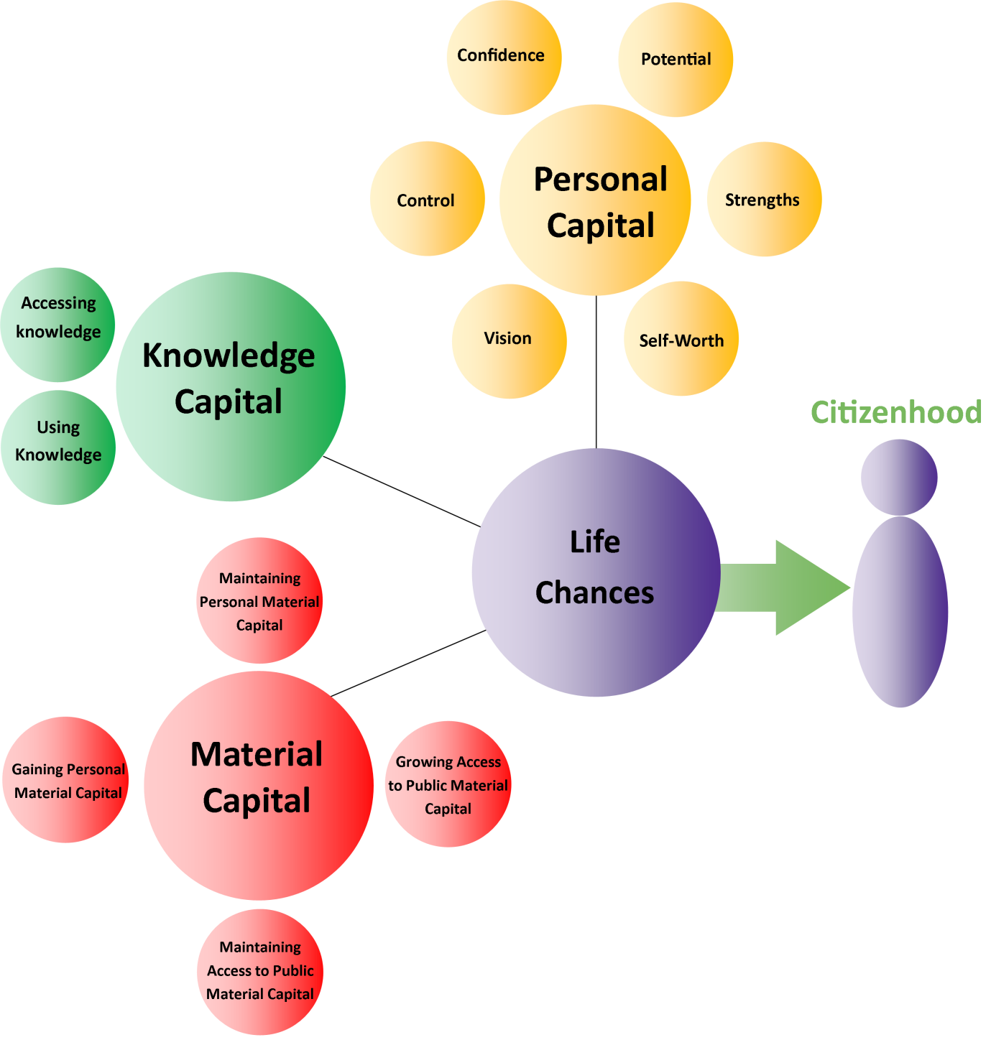

Social Capital
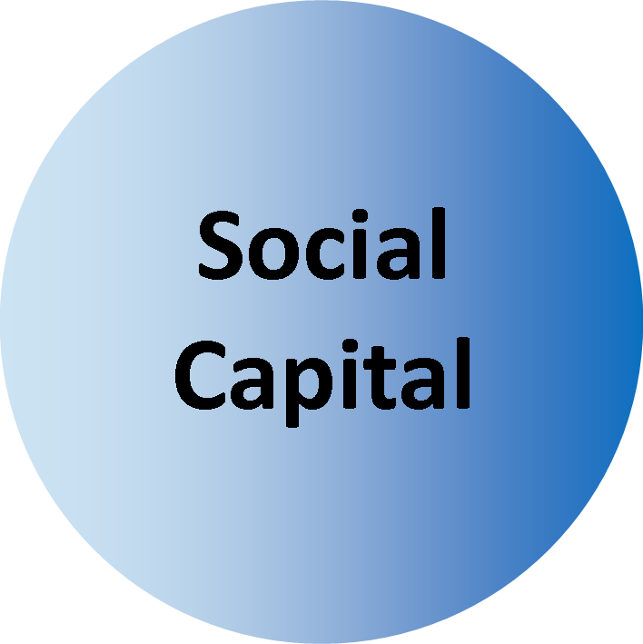

The Elements of Social Capital
Earlier this monograph identified the presence of interdependence in our lives, and how this leads to the building of neighbourhoods and communities. Human contact lies at the heart of such interdependence. Such contact allows us to transact our specific personal business and also represents an asset in itself. To know people, to have contacts, gives us a platform for fulfilling a range of needs and wants. From among our contacts we might know someone who knows someone else who has a job opening that might interest us, or who knows a good plumber, or who introduces us to someone who becomes a lifelong partner, lover or friend.
The power and importance of social connection is illustrated by the exponential growth in popularity of online communities like Facebook and LinkedIn as significant mechanisms by which people develop and maintain connections. The nature and extent of this connectivity represents Social Capital, and is an asset that can be used to help advance a person's life chances.
There are two main aspects of Social Capital; these are Connection and Fellowship.

Connection refers to the extent to which we have contact with other people. This can include people we know at work, people who live in our street, people who go to the same club, the regular bus driver on our regular bus route, the person we regularly see at the checkout at our local store, and so on. It can also include contacts in online communities. Some of these contacts we may see every day, others less often. What makes these contacts important is that they carry meaning for us and can variously connect us to a wide range of opportunities which can help meet our needs and wants.
Fellowship refers to connections that have moved beyond their initial functional or situational nature to become a relationship where there is deeper mutual regard, the development of trust, and the establishment of a bond. Without Connection it is very hard to achieve Fellowship. For example, a particular person may not have become our acquaintance (Fellowship) had we not first met them at our previous place of employment (Connection); a particular person may not have become our life partner (Fellowship) had we not first met them at a party (Connection) organised by a mutual friend (Fellowship) who we know because they live two doors down the street (Connection).
These elements of Connection and Fellowship represent social assets, or Social Capital, we can draw on to advance or uphold our chances of a good life, a valued life characterised by active Citizenhood.

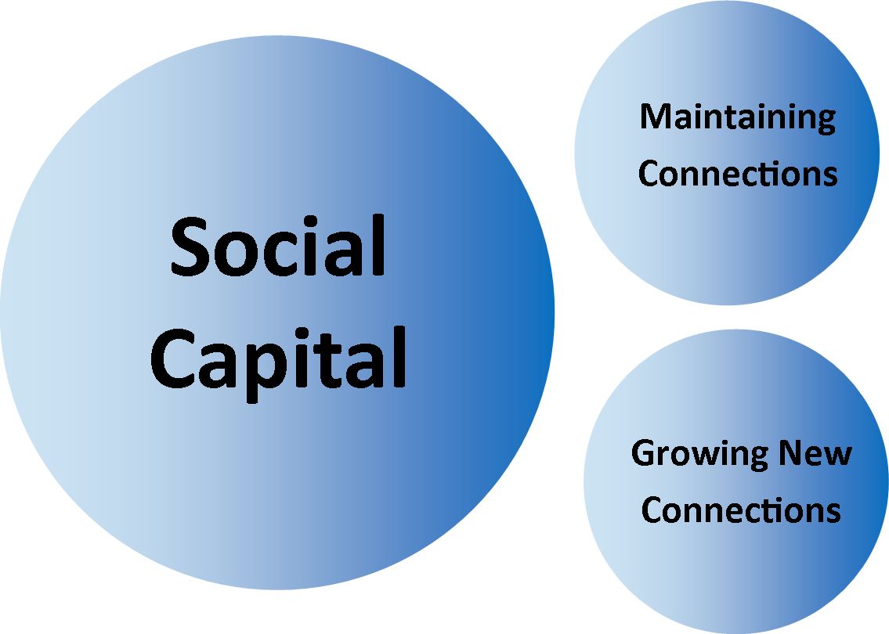

Distance from Social Capital

The Assumption and Impact of Service Recipiency
For many people living with increased vulnerability, the service agencies that provide services are sometimes focused on the goal of service delivery itself rather than the life chances it is meant to support. In other words, the person’s day, even the person's identity, is defined by the receipt of services. For example, one of the ways an underfunded disability support system might impact a person is if they are only provided support to take a shower three or four times a week. In such a situation, the reported advantage of a better funded system would be that the person is supported to have a shower every day. While many of us would agree that a daily shower is important and pleasant, it does not represent the highlight of our day. Instead, along with other daily rituals, it helps prepare us for the other things we want to do in our day.

To know people and to have contacts gives us a platform for fulfilling a range of needs and wants

Unfortunately, for many people living with increased vulnerability, daily life is characterised by the receipt of services and not much else; as though the goal of service delivery seems to be to get people clean, dressed, fed, moved and “therapied” with the rest of the time being “filler”. In this way, people are at risk of being trained to see their life goals in terms of service recipiency rather than, say, growing social networks. Put crudely, the emphasis is placed on “I need a daily shower and I need my therapy” instead of, “I need a life”.
When services are not seen in the context of advancing the person into a valued life of active Citizenhood and instead become an end in themselves, there is a risk that they are scheduled to serve the convenience of the service agency rather than the advancement of the service recipients. This can create uncertainty for the person about when they will get their assistance and in turn can have an adverse effect on a person's social calendar.

The Problem of Special
Typically we acquire and build connections throughout our lives. This starts with family and neighbours, and continues in preschool, primary school, high school, further education, our first job, our second job and so on. We also acquire and build connections as we move into different roles in life, such as parenthood and retirement. We also acquire and build connections through our personal interests, like sports, hobbies, travel etcetera.
Almost every day there are opportunities to exercise our connections and make new ones, and these in turn can create opportunities for even more connections. Unfortunately, people living with increased vulnerability do not necessarily access the same pattern. When a person is born into, or moves into, a life of increased vulnerability they may have a lower or diminished capacity (Personal Capital) to move into opportunities that build connections. This has the obvious impact on Social Capital, which in turn will have an adverse impact on future opportunities.
Unfortunately a typical system response to this has been to set up special opportunities or services for the person, albeit with hopefully good intentions. Yet such special arrangements have a tendency to create even greater distance between the person and Social Capital. For example, a person born with severe disability might be provided with special early childhood services. The connections created by such services are likely to focus on connections with professional staff, other families and people in a similar situation. These connections can be valuable and valued so there is some Social Capital arising, but they don't adequately produce a typical range and breadth of connections for a person at that point in their life.
Next, the person might be enrolled in special education. It seems not many young people living with severe disability make it into a local mainstream primary school, perhaps even fewer make it to the local mainstream high school. The connections created by such education will likely focus on connections with professional teaching and support staff, and other students living with similar disability and their families.
Again, these connections can be valuable and valued, but they don't adequately produce a typical range and breadth of connections for a student at primary school or high school.

The person will then likely be enrolled into post-school options. Apart from the lucky few who might be assisted into authentic waged employment with a mainstream employer, the main options include special types of further education designed to “train” people for daily adult life, day programs which tend to focus on recreation and respite, or work in special enterprises whose main employees are people living with similar vulnerability and receiving a “pocket money” wage.
The connections created through these special adult services will likely focus on connections with professional support staff, other adults living with similar vulnerability and their families, and possibly some contact with the public depending on the nature of the special enterprise. Once again, it is entirely understandable that such connections are valued by the recipients and counted as Social Capital, and will often be given as a primary reason for justifying their continuing attendance. However these connections do not adequately produce a typical range and breadth of connections for adults of working age.
Given our social connections create opportunities for further social connection; the effect of special services is to reduce the chances people will find more social connections in the future. It can be argued that the more time a person spends in the narrower range of connections created by special services, the less likely it is the person’s range of ordinary social connections will expand, and the person’s Social Capital will therefore be restricted to the networks created by those special services. This in turn would increase the person's dependence on special services for their social connections, often resulting in the person expressing reluctance to move on from such service settings because of the loss of such connections (this is then cited by some agencies as “proof” that such service settings are “right” for the person).
This becomes a vicious cycle. A person with lower capacity to build social connections is referred to special services. By their nature, special services present narrower opportunities to access and build ordinary social connections. This inhibits the advancement of the person's Social Capital, giving rise to the need for more special services.

This pattern of support, where a person's Social Capital narrows and contracts as a result of using special services, also has an adverse effect on people within the wider community, who unknowingly are denied the opportunity to meet and get to know fellow citizens who, despite living with increased vulnerability, have strengths and gifts to bring to community life and who, through their presence, can have a positive impact on their non-disabled fellow citizens. As a result, the Social Capital of citizens in the wider community is diminished; but typically they don’t know it, therefore are far less likely to do anything about it.

The Tyranny of Special
As illustrated above, the way people receive their assistance can have a contracting effect on Social Capital. For some people, the experience of certain types of special services can result in such a diminishment of their capital, that their Social Capital shrinks to zero and can move into a negative value. Let’s look at a hypothetical example. A young adult man living with severe intellectual disability is placed in a special service – a group home – because of difficulties in previous accommodation with family. The difficulties are described as behaviour issues, and the special service is set up to support several people who have these labeled behaviour issues but who may have nothing else in common. The routines within the special service are focused on reducing the possibility of incidents as a result of these behaviour issues. As a result, there is little opportunity to spend time in the wider community and the days are focused on household routines which, even to the casual observer, might be regarded as dull.
At the first signs of any difficult behaviour, the special service staff follows protocols that restrict the possibility of the behaviour continuing. These restrictive practices place immediate limits on the person’s freedom, and the man does not like this at all. Very few of us are completely comfortable with restrictions placed on our freedom.

As time passes this young man chooses actions which are increasingly antisocial. He chooses these actions perhaps because he is bored, sad or lonely, or because he dislikes the character and habits of the people he lives with, dislikes the restrictive practices, or dislikes the procession of paid staff who move through his life and tell him what to do. The antisocial actions he chooses greatly reduce his chances of building connections into community life. The staff spend more and more of their time actively restricting his movements, and they come to dislike him because of his extremely antisocial actions, which makes them less likely to warmly engage with him and more likely to initiate restrictive practices at the first sign of trouble.
Over time this young man is assigned a highly negative reputation, resulting in people (including the people paid to be there) not wishing to spend any more time with him than necessary. Bereft of any remaining Social Capital because there are no longer any warm social connections in his daily life, this young man takes whatever human contact he can find, which is typically when staff have to engage with him because he is doing something deeply unpleasant. His antisocial behaviour becomes more and more extreme which results in a larger ratio of staff working with him at any given moment. Given he has no other social connections in his life, he sees this increased staff presence as his only social contact – a perverse shadow of Social Capital – and this in turn makes it more likely he will continue to choose deeply antisocial actions as a way of initiating such contact from staff.
In this way, and in the name of good intention, the service arrangements have resulted in the diminishment of any Social Capital in this young man's life and replaced it with a deeply negative social reputation that could stay with him his entire life. As the relationship deepens between his antisocial behaviour and the increased staff restrictive response, the costs of service provision will increase but deliver poorer outcomes. This desperate situation might have been avoided had there been a more proactive focus at the outset on establishing ordinary, valued social contacts.

Building Social Capital – Statement of purpose
Building Social Capital is about growing the number and range of active social connections in a person's life, so that the person’s daily routines are rich with opportunities to connect with people, and rich with the possibility that those connections will give rise to additional new connections and deepen into Fellowship.
Given the importance of Social Capital in our lives – both as a gateway to new possibilities and also as an important source of wellbeing in terms of belonging and companionship – it is critically important that a person living with greater vulnerability is supported to build and maintain Social Capital, to help advance their chance of a good life, a valued life of active Citizenhood.
People need to be able to access Social Capital in support of active Citizenhood. This includes maintaining (upholding) current Social Capital and also growing (advancing) Social Capital.
If a person needs assistance because of increased vulnerability, the formal agency (or individual agent) has a fundamental obligation to uphold that person’s Social Capital. This means the agency must carry out its endeavours in ways which help maintain, and do not inadvertently undermine, the person’s social connections.
Similarly, the agency or agent formally involved in the life of a person living with increased vulnerability can also play a key role in supporting the person to advance Social Capital, by organising its supports in ways which continuously present opportunities for the person to make new connections in mainstream community life.
While Social Capital includes the elements of Connection and Fellowship, the support agency cannot directly deliver Fellowship into a person's life because Fellowship cannot be artificially manufactured via a service process. Fellowship emerges organically from the connections people have with others. This means a support agency cannot guarantee the delivery of acquaintances, friends, companions, lovers or partners into the life of a person living with increased vulnerability. Instead, the agency might focus its efforts on supporting the person in a way that builds the range of positive, natural connections in that person's life – connections with neighbours, connections into mainstream working life, connections through personal interests, connections through being a customer, and so on.
I take a moment here to reflect on how paid support staff can sometimes see themselves as key Social Capital to the person. I have heard staff claim they are a friend to the person to whom they provide support. It is not unusual for people to meet through work and become friends, so it is entirely possible that as a result of supporting a person with increased vulnerability, the supporter develops a genuine warm regard for that person and wishes to enjoy a personal connection outside working hours and stay personally connected beyond the life of the working relationship.
This is problematic for a number of reasons. First, there is the question of whether the word ‘friend’ is being used correctly. The supporter might be using this term to describe how they feel friendly towards the person and that they find the person likeable. They might also be using the term to symbolise their solidarity with the person, including those times when they might find themselves asserting the person’s interests to a third party.
These are good sentiments, but in and of themselves they do not constitute authentic Fellowship. Instead, the unintentional misuse of the word ‘friend’ signals the supporter’s desire to do a good job for somebody they like. For the person living with increased vulnerability, the risk of having someone use the term ‘friend’ in this way might mean the person comes to believe that this is the extent of friendship in life; warm regard from someone providing aid assistance. This can close off, or otherwise reduce, the emergence of more authentic friendships in the person's life. In other words, in declaring their status as a friend to the person, the support worker may mistakenly conclude that this infers some measure of adequacy in the person’s Social Capital and therefore there is less of a need to assist the person to make new connections which could lead to genuine Fellowship.
The second problem is when authentic Fellowship has emerged, such that the paid supporter has two roles in the person's life; one as a paid person offering formal support, and the other as a friend or acquaintance. This needs to be navigated extremely carefully. For example, it is not unusual for any of us to seek the advice and input from friends and acquaintances when considering a decision or choice. Therefore this is also true for a person living with increased vulnerability. For that person, the advice and input from a friend may come from a different perspective compared to that of a person in a formal support role. For example there may be different perspectives on risk tolerance, and there may be competing interests. It will be hard for a paid support worker to give advice as a friend that is different to the advice their employing agency wants them to give.
It will be complicated to resolve which perspective takes prominence in a particular situation, and it will not be easy to manage the possible consequences for the other role.
Interestingly, this problem can also emerge in reverse, where the non-disabled person who is a friend or acquaintance becomes involved as a formal support person. The perceived difficulties of managing the boundary between freely given friendship and paid personal support is illustrated by the policy struggles jurisdictions have when considering if friends and families can be employed as support workers by a person who has Individualised Funding. More generally, many people have had personal experience of some of the problems that emerge when a person becomes an employee of someone who is a family member or a friend.

Upholding and Advancing Social Capital – Considerations

Upholding Social Capital – The Art of the Executive Assistant
Given its importance, we seek ways to maintain Social Capital in our lives. For example meeting friends regularly, picking up the phone, doing our grocery shopping in familiar stores where there are familiar faces, remembering people's birthdays and anniversaries, making the time to say hello to our neighbours over the fence, and using online communities to help ensure we don't lose contact with people we know. Some people living with increased vulnerability may need support with these interactions. This means service agencies need to find ways to conduct their support to the person in ways that maintain, and certainly do not disrupt, this Social Capital.
The first task is to get to know the person well, and part of this is to understand the range of Connections and Fellowships the person has in their life. The service agency then needs to build support arrangements around the person that, among other things, are anchored on regular and routine opportunities to maintain (and possibly advance) the quality of these Connections.

This means that whatever the degree of formal support available to the person, it needs to be arranged in a way which includes assistance to the person to maintain social connections (unless the person is clearly maintaining their social connections without the need for such assistance). If the entire amount of available paid support is used on personal care and household tasks, it is not a complete solution because it does not attend to the person’s social connections, and the person’s Social Capital is in danger of diminishment as a result. This means the service agency needs to work harder to find a better solution. This might include a more creative approach to the use of staff time, for example working with the person to develop the availability of natural, freely given assistance, or by building more flexibility into support staff rosters to better support a person’s social life (for example the Stay up Late campaign in the UK).
In essence, the support agency staff needs to see part of their role as similar to that of an Executive Assistant in public and private organisations. The Executive Assistant supports an Executive by coordinating the person’s schedule and undertaking the tasks which support that person's goals. This includes being proactive and initiating arrangements, often involving creating arrangements for the Executive to spend time with various people for various reasons. To do this work well, the Executive Assistant needs to have a sound understanding of the Executive’s goals and priorities and the people the Executive needs to meet, so they can ensure the schedule has the best possible fit.
Applying this analogy to the lives of people living with increased vulnerability, it means the agency worker needs to be highly mindful of the person’s current range of valued social connections – their Social Capital – and what arrangements can be put in place to help ensure the person exercises those social connections.

There is an art to this role that comes from both getting to know the person well enough to take actions and make decisions that are demonstrably supportive of their goals and aspirations, while at the same time not overstepping the mark in terms of who is truly in control. Typically in public and private organisations, there is little dispute over who is in control because one person is the Executive and the other person is the Executive Assistant. However, when we apply this relationship to a situation where a person with increased vulnerability is being supported by an agency worker the locus of control becomes less clear, particularly when the person being supported has increased vulnerability in decision-making. Under such circumstances there is a greater onus on the agency worker to have the wisdom and mindfulness to know when to take up the initiative and when to hold back.

Advancing Social Capital – The Art of Introductions
For many people living with increased vulnerability there is an imperative for agency or agents to assist the person to advance their social connections. Otherwise there is a risk the person's life will be characterised by paid relationships. There are a number of ways this might be achieved.
One possibility is to directly recruit people into the person's life to intentionally develop a network to assist the person with decisions and opportunities. An example of this is the body of methodologies termed Circles.
A second possibility is to create opportunities for social connection by drawing on the other Capital in the person's life; after all, this is how people tend to make social connections. For example the person may have Personal Capital (their desire to help) and maybe some Knowledge Capital (a particular skill or strength) and/or some Material Capital (their own time, access to a vehicle, a phone etcetera) that is useful to a person or group that needs it. The task then is to find opportunities to offer this Capital. This creates an imperative for the support agency to develop a deep understanding of what is going on in community life, to continually operate a ‘radar’ for opportunities where the person's Capital might be helpful. Such a situation might include a community group looking for volunteers to help with various practical tasks where it is conceivable the person, with or without support, can assist.

The challenge for service agencies is to see these possibilities and create introductions to help them happen. But it is not yet enough for the agency to deeply know a person and their aspirations and to also know where opportunities lie within the local community. The agency (or agent) also needs to be mindful about how to craft such introductions. This can be a challenge because many agencies only look to the resources within the agency – either staff or material assets (or the informal agent such as a family member only considering their own personal resources including their time) – as the primary way to meet a particular person's interests. If such resources can't easily be applied, the interest goes unmet. This is a problem because even if the agency did have the resource or material asset available to directly meet the interest without the involvement of anyone else, an opportunity has been lost for connecting the person to others within community life.
So the challenge here is for the agency or agent to craft introductions into community life that are not dependent on the agency/agent’s own resources to sustain them. It is critically important that agencies find ways to craft such introductions because they can be a foundation for building Social Capital. This means some agencies will need to completely rethink the nature of staff assistance and build their capacity in community navigation and introduction.

Advancing Social Capital – The Art of Building a Welcoming, Integrated Community Life
While strengthening the accessibility of community amenities is deeply important, as set out in section 8.4.5, by itself it does not guarantee people living with increased vulnerability will be actively included in the life of the wider community. For example it is entirely possible to have an accessible library in terms of its physical or material characteristics that still excludes people living with increased vulnerability. While this might be due to a failure to adequately connect with the specific material requirements some library users may have, it can also be because of the limited capacity of the staff to personally connect with people living with increased vulnerability.

Problems of connection might include a lack of familiarity with, or technical knowledge of, the person’s circumstances. Also problems of connection might relate to an absence of warmth in the contact, where a staff person might suspend normal habits of welcome because they see the person is somehow different to most customers and perhaps requires a special technical approach the staff member is not familiar with. Such attitudes are perhaps not surprising because for many years people living with increased vulnerability, such as severe disability, have been accessing patterns of service that often separate them from mainstream community life. Therefore it might be harder, for example, for the library worker to act naturally in the presence of a person living with severe disability if the library worker has not previously had the opportunity for natural encounters with such customers.
The result is an absence of authentic habits of welcome, and this is a much more fundamental issue than the absence of training on the technical considerations relating to a customer living with increased vulnerability. When we artificially close ourselves off to our natural traditions of welcome and hospitality, this inhibits our capacity to engage in problem-solving with the person. This is unfortunate because many of the practical issues that lie between a person living with increased vulnerability and a good life are solvable through practical thinking fuelled by compassion and “un-common” sense.
Arguably, people living with disability could have greatly improved life chances if they were able to access education on the same basis as their non-disabled peers. While such a public policy commitment would have specific requirements for the physical and technological accessibility of all Australian schools, the bigger challenge would be how to build authentic habits of welcome in our local schools. This is much more than a single-dimension notion of hospitality. It is about how each of our school communities understands and values diversity in the classroom and across the school community. It is about the school's attitude to problem-solving on issues of access and integration. It is about the school's technical capacity to design an individual learning profile for each student. In these ways the school affirms the student’s sense of belonging in their local community.

Given the often low levels of personal experience many people in community life have with their fellow citizens who live with disability, there is an imperative for the agency or agent to model this in a natural, affirming way when supporting people in community and particularly when effecting introduction, to help build the community’s capacity to give an authentic welcome. A first step will be for the agency to reflect on how they currently support people in community life and how this is likely to be observed by other members of the local community. This includes being more mindful of practices that do not advance (and in fact usually restrict) the broader community’s capacity to be welcoming. This might include the way people living with disability are organised into groups to access community opportunities (for example, two minibuses of people living with disability going on an outing to the ten-pin bowling centre), and also the way some agency staff (or other agents) may be running their interpersonal transactions with the people they support, reinforcing passivity and patronage.

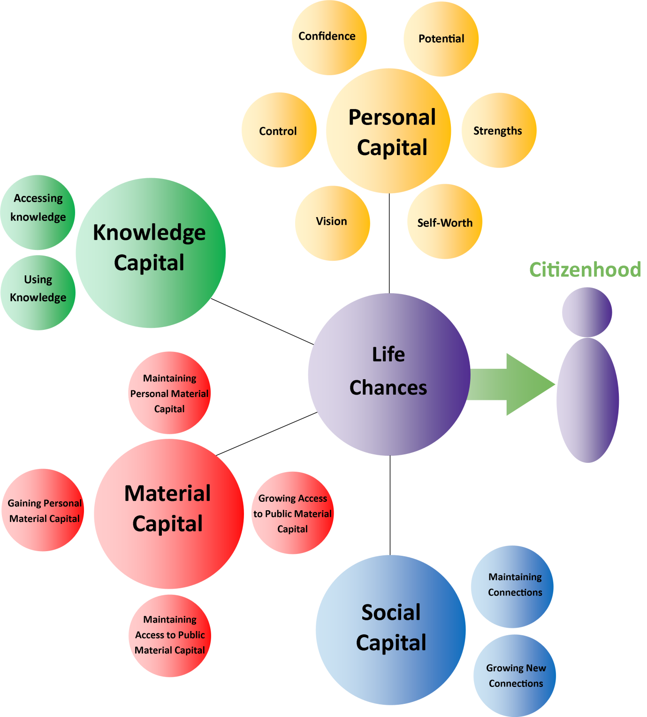

Surveying a Person’s Life Chances using the Four Capitals
The Model of Citizenhood Support provides a framework for considering a person’s life chances, and ways to understand and build upon those life chances by thinking about the person and the four different types of Capital in their lives. The Model also provides a valuable opportunity to map a person’s current situation, by measuring the presence of the Four Capitals across typical lifestyle areas.
The following Life Chances Survey (with acknowledgment of the Q50 for source material) takes six areas of lifestyle and poses a set of statements about Capital. These statements reflect one or other of the Four Capitals within the Model of Citizenhood Support. There are 49 statements in total.
This survey is designed to assist a more detailed understanding of a person’s current life chances. It can be used to augment, but not replace, a natural conversation with the person.

The six key areas of lifestyle are:
- About Home
The place where the person sleeps, so these statements also apply to persons who identify themselves as homeless.
- About Health
The person’s physical and psychological wellbeing.
- About Daily Living Routines
The things a person does to maintain self and surroundings – personal care, housework, meal preparation, shopping, paying bills etcetera.

- About Occupation
This is not just about work. It covers all activities (outside daily living routines) that meaningfully occupy a person, such as work, recreation, education etcetera.
- About Relationships and Belonging
A person’s family, friends, acquaintances, neighbours, co-workers, formal and informal memberships, including cultural and spiritual identity.
- About Choice and Voice
a person’s decision-making and opinions, and what fuels this (in essence, this maps the current extent of the person’s Personhood).
For each of the six areas of lifestyle, the rater (which could be the person themselves, a significant other, or someone in a helping role) chooses a score between one and five (where one (1) represents “Strongly disagree” and five (5) represents “Strongly agree”) as per the scale next to each statement. For example, the first statement reads “I chose where I live and who I live with”.

If the rater:
- strongly disagreed with this statement about their situation, they would select the score of 1
- somewhat disagreed, they would select the score of 2
- neither agreed nor disagreed, because some choice was present but some was missing, they would select a score of 3
- somewhat agreed with the statement, they would select a score of 4
- strongly agreed with the statement, they would select a score of 5.
The scores can be generated by directly posing the statements to the person and recording their responses, or by the rater forming a conclusion about each statement based on a more general, natural conversation with the person, followed by checking the ratings with the that person.
Once the person’s situation has been considered using all 49 statements, there will be 49 different scores. These scores can be aggregated to variously provide a measure of the person’s current life chances overall, and in terms of the person’s:
- home life
- health
- daily living routines
- occupation, including income
- relationships and sense of belonging
- choice-making and voice
- Personal Capital
- Knowledge Capital
- Material Capital
- Social Capital
Importantly, the tool can be applied subsequently to chart any changes in the above as a result of new actions and resources. As such, it is an outcome tool, because it attempts to quantify elements of life chances as defined within the Model of Citizenhood Support.

About Home
Statement | Strongly Disagree | Strongly Agree
I chose where I live and who I live with. | 1 2 3 4 5
I live in a good house; it reflects who I am and because of it, other people see me in a positive light. | 1 2 3 4 5
My house is arranged so I can use the skills and knowledge I have, and I can learn new things too. | 1 2 3 4 5
I have valued possessions at home that are taken care of. | 1 2 3 4 5
I have control over what happens in my house; I make the decisions. | 1 2 3 4 5
I feel safe where I live. | 1 2 3 4 5
From home, it is easy for me to access local amenities in my local community. | 1 2 3 4 5
My home makes it easy for friends/family to visit. I know my neighbours well, and lots of people know me in my neighbourhood. | 1 2 3 4 5
My current home arrangements are unlikely to change for the worse in the near future. | 1 2 3 4 5

© JFA Purple Orange 2013. All rights reserved.

About Health
Statement | Strongly Disagree | Strongly Agree
I take charge of my health and I have a positive outlook. I am making choices that support good health. | 1 2 3 4 5
I have good knowledge and skill about what I need to do to keep myself as healthy as possible. | 1 2 3 4 5
I have personal resources and material supports that help me stay well. | 1 2 3 4 5
I can easily access help with my health when I need it. | 1 2 3 4 5
I can easily connect with other people who have similar health interests or issues. | 1 2 3 4 5
My current health is unlikely to change for the worse in the near future. | 1 2 3 4 5

© JFA Purple Orange 2013. All rights reserved.

About Daily Living Routines

Statement | Strongly Disagree | Strongly Agree
I choose and am in control of my daily living routines. | 1 2 3 4 5
My daily living routines help me to present myself in the best possible light so that I can get things done in community life. | 1 2 3 4 5
My daily living routines reflect what I know and can do, and are arranged so I can learn how to do more for myself. | 1 2 3 4 5
I have enough resources to help me with my daily living routines. | 1 2 3 4 5
My daily living routines involve me using public resources like transportation, the shops etc. | 1 2 3 4 5
My daily living routines bring me into regular contact with other people in my community. | 1 2 3 4 5
My daily living routines are unlikely to change for the worse in the near future. | 1 2 3 4 5
© JFA Purple Orange 2013. All rights reserved.

About Occupation

Statement | Strongly Disagree | Strongly Agree
My occupation reflects who I am and what I like; other people value my work and I am contributing as a citizen. | 1 2 3 4 5
My occupation reflects my knowledge, skills and gifts. | 1 2 3 4 5
My occupation gives me regular opportunities to grow my knowledge and skills. | 1 2 3 4 5
My occupation brings me a fair living wage. | 1 2 3 4 5
I have access to material supports to help find and keep valued occupation. | 1 2 3 4 5
Public transportation, accessible buildings etc. make it easy for me to find and keep occupation. | 1 2 3 4 5
My occupation brings me into regular contact with a wide range of people; I meet new people regularly. | 1 2 3 4 5
My current occupation arrangements are unlikely to change for the worse in the near future. | 1 2 3 4 5
© JFA Purple Orange 2013. All rights reserved.

About Relationships & Belonging
Statement | Strongly Disagree | Strongly Agree
I chose to be involved in the groups I belong to. | 1 2 3 4 5
My relationships and my group memberships show me in a valued light in the wider community. | 1 2 3 4 5
My group memberships reflect my knowledge and skills, and are also a place where I can grow. | 1 2 3 4 5
I have access to personal resources and supports to be able to maintain my relationships, and participate in cultural and other groups that are important to me. | 1 2 3 4 5
Public transportation, accessible buildings etc. make it easy for me to maintain my relationships and participate in my cultural and other groups important to me. | 1 2 3 4 5
My cultural identity and group memberships bring me into regular contact with a wide range of people; I meet new people regularly. | 1 2 3 4 5
My relationships and my cultural/group memberships are unlikely to change for the worse in the near future. | 1 2 3 4 5

© JFA Purple Orange 2013. All rights reserved.

Statement | Strongly Disagree | Strongly Agree
I can easily see potential in myself. | 1 2 3 4 5
I have strengths and gifts that can help me move towards a good life. | 1 2 3 4 5
I feel good about who I am and the value I can bring to the world. | 1 2 3 4 5
Other people easily see the positive value in me. | 1 2 3 4 5
I have clear and positive ideas about what a good life could be like for me, and how I can make progress towards this good life. | 1 2 3 4 5
I have control of the important decisions in my life. | 1 2 3 4 5
In making my choices and forming my opinions, I make full use of what I know and I can easily access information about my options. | 1 2 3 4 5
There are ways available to me to continue to grow my knowledge and skill at making decisions. | 1 2 3 4 5
I have access to personal material resources that help me to communicate my views and choices. | 1 2 3 4 5
Expressing my views and making my choices bring me into regular contact with a wide range of people; I meet new people regularly. | 1 2 3 4 5
My arrangements for making decisions and giving my opinions are unlikely to change for the worse in the near future. | 1 2 3 4 5
About Choice & Voice
© JFA Purple Orange 2013. All rights reserved.

The Interrelationship between the Four Capitals and the Implications for Agency (or Agent) Support; Building an Authentically Helpful Relationship
The previous sections have described the importance of attending to four different types of Capital to help build a person’s chances of a good life, a valued life of active Citizenhood. There is a strong interrelationship between the Capitals, with each one having the capacity to influence the others. For example, in thinking about how to build a person's Personal Capital, elements of the problem might include poor access to information and advice (issues of Knowledge Capital), poverty of personal material resources (issues of Material Capital), the development of passive service recipiency because of the nature of support arrangements (issues of Material Capital) and social isolation and loneliness (issues of Social Capital).
All sections of this monograph have included consideration of the role of the formal agency (or agent) upholding and advancing each of the Four Capitals. To provide support helpful to a person, an agency needs to reflect on the nature of the relationship it builds and maintains with the person. The nature of this relationship will determine the extent to which the agency is providing authentic helpful assistance as opposed to intervention or even interference.

Considerations for the agency or agent, to help navigate to a relationship more likely to be authentically helpful to a person in terms of upholding and advancing the Four Capitals towards a valued life of active Citizenhood

This final section focuses on considerations for the agency or agent, to help navigate to a relationship more likely to be authentically helpful to the person in terms of upholding and advancing the Four Capitals towards a valued life of active Citizenhood.
The section is structured as a twenty-question enquiry, to assist the formal agency (or informal agent) reflect on how helpful their assistance truly is to the person’s life chances.

Twenty Questions about Authentic Helpfulness
The Model of Citizenhood Support generates an initial series of 20 Questions to assist an agency to understand the extent of its authentically helpful relationship with each person it serves. The questions are linked together, beginning with the context of Citizenhood and then moving through each of the Four Capitals.
Each question has implications for the agency’s stated values, vision and mission, strategy, use of material resources, approach to recruitment, development and retention of workforce, and the agency’s culture and leadership.
Question 1 (Citizenhood)
To what extent do the agency and its staff believe in the possibility that this person can live a good life, a valued life of active Citizenhood?

On the face of it, this may appear a simple question. Sometimes a question appears simple because it carries fundamental importance.
It is possible a service agency (or agent) might consider answering “no” to this question, perhaps on the assumption the person’s severe and multiple disabilities means they cannot play a valued role in community life. This is an unhelpful perspective and can be deeply harmful to the person as it may set the context for the supports the person receives. Such a context dismisses the potential for the person to make a contribution through their presence in mainstream community life, invoking values of humanity, diversity and understanding.
If an agency answers “no” to this question, it may be best that they withdraw from their involvement in the person's support because of a self-imposed constraint on helpfulness.
Perhaps most agencies would answer “yes”. If so, this needs to be properly considered because it represents a serious undertaking. If the agency believes in the possibility the person can live a good life characterised by Citizenhood, this means everything the agency provides to the person needs to demonstrably advance the person towards this good life and defend it.
This leads to the second question.
Question 2 (Citizenhood)
To what extent is this agency prepared to be held accountable for authentically advancing a person towards a good life of active Citizenhood?

Every field of human endeavour involves a set of hoped-for outcomes, a bottom-line. Typically, this is then measured in some way so there is accountability.
Therefore there is little point in an agency committing to advancing a person's life chances if it is not prepared to be held accountable for this; in which case a “no” answer might again herald the withdrawal of that agency’s involvement in the person's support.
A “yes” answer means the agency is committing to its performance being scrutinised via both internal mechanisms of self-reflection and external mechanisms of independent audit.
Question 3 (Personal Capital)
To what extent does the agency truly know the person, as a result of careful enquiry and listening, in the context of the person’s potential and strengths?

For an agency to build an authentically helpful relationship, it first needs to develop a deep understanding of the person’s story, as told by the person themselves and the trusted others in their life. The line of enquiry, and the character of listening, must be anchored on affirmation of the person’s potential and strengths, together with an appreciation of the person’s current circumstances in relation to good life chances.
To respond to this question, consider the agency’s current approach to getting to know the person it seeks to serve, and the extent this results in an affirming, well-rounded understanding of the person.
This includes understanding the person’s history of experiences, which gives rise to the next question.

Question 4 (Personal Capital)
To what extent does the agency honestly reflect on the impact of past experiences on the person’s life chances?

People's life experiences either add to, or diminish, their future life chances. These life experiences include experiences receiving services. There are many, many stories where people living with disability (or other types of increased vulnerability, including poverty) have had experiences that have diminished their life chances.
For an agency to develop an authentically helpful relationship with the person it serves, it needs to develop a deep understanding of the person’s history, including their past experience of services. For this analysis, the “past” includes services delivered five minutes ago. This can be difficult, for it means the agency may need to reflect on the extent its own services have harmed the person's life chances. However it is an essential line of enquiry because it deepens the agency's understanding of the person and also gives the agency the opportunity to abandon any such harmful efforts, however well-intentioned, and to set the situation straight.
This gives rise to the next question.
Question 5 (Personal Capital)
To what extent does the agency undertake a proactive, sustained effort with the person to heal “wounds” caused by past and present service and life experiences?

Once the agency has documented aspects of the person's history that have created “wounds” to their Personal Capital, the agency needs to take all necessary steps to assist the process of healing. As we have seen in Australia in other areas of human endeavour, this might begin with a sincere acknowledgement of the harm caused and also an apology, particularly if it has been due, even in part, to the agency's own efforts.

Whatever the issue, the agency needs to ensure the process of truth, reconciliation and healing results in an evolution in how the agency arranges support. There is a compelling moral and ethical imperative for the agency to change/remove any practices (whether it conducts these practices itself or commissions them from elsewhere) that can be linked to the emergence of known harms.
In support of such evolution, the agency needs to lead or contribute to a healing process that makes sense in relation to the person's personal circumstances. Here are two examples.
Adoption of unusual or antisocial behaviour
For some people, their previous experience of services or of life in general has resulted in their adoption of unusual or antisocial behaviours. This can reduce their Personal Capital in the eyes of others and can make it harder for the person to move into roles of Citizenhood. In these situations, it will not be enough for the agency to simply ‘manage’ a person's current repertoire of behaviours. This is because such an approach focuses on managing a problem, and efficient outcomes will be limited to a reduction in the harmfulness or intensity of the behaviour. Instead of managing a problem the agency needs to focus on supporting a good life. This involves the agency taking a thoughtful and persistent approach to address the underlying causes of the behaviour, and assisting the person to adopt habits that strengthen their Personal Capital and are more conducive to the achievement of Citizenhood.
Diminished personal vision
As a result of the experience of waiting and asking for services, together with the messages communicated by some system stakeholders, a person can develop lower expectations about what's possible in their life, and instead become a passive service recipient, treading water in difficult situations and fearful of losing what little support they have. For such situations, the agency needs to invest time and resources in assisting the person reclaim the right to imagine a good life. This may include assisting the person to connect with advocacy groups and other types of independent assistance, and may also involve the agency’s support of the person to transfer to different support arrangements that can better uphold and advance the person’s access to good life chances.
This gives rise to the next two questions.
Question 6 (Personal Capital)
To what extent does the agency uphold the person's central role as the decision maker, the author of their own life?
For people and family who have become passive service recipients (or frustrated waiting-list inhabitants) where much of the control has rested with agency/system professionals, it is critical they are supported to take up a central role in the decisions that affect them.
This means the agency needs to reflect on the way decisions are made, and how the intended beneficiaries are involved. The bottom-line is that the agency needs to be supporting the person to make their own decisions, not making decisions for them. Typically this takes a lot more effort and might include decisions contrary to the agency's other interests. This means the agency needs to be deeply mindful of how it supports a person to make decisions, and with whose interests in mind.
This is no less true when supporting a person who apparently has more difficulty in making decisions, and who may even have a substitute decision maker (for example a formally-appointed guardian) in their life. This person can still be assisted to remain at the centre of the decision-making process so that the decisions made are more likely to reflect the person's own interests.
This gives rise to the next question.
Question 7 (Personal Capital)
To what extent does the agency support the person to develop and move towards a personal vision of active Citizenhood supported by good life chances?
Most agencies will claim they undertake a planning approach focused on the individual person. Increasingly, agencies are adopting language and methodologies such as person-centred planning to reinforce this claim. However, there are a number of traps the agency needs to honestly assess itself on (and lay open for scrutiny by independent others). Some, but not all, are outlined below.

One trap is service-centred personalised supports. This is where the agency uses an approach that claims to be person-centred but in fact is focused on allocating its own services. In other words the person is supported to make choices in a plan that primarily focuses on the agency's own services. This means the context of the conversation is service provision rather than the person accessing good life chances.
Another trap is overreliance on planning methodologies. Some agencies have adopted planning methodologies that claim not to have services as a context. Those same agencies invest time and resources training their staff to be accredited planners within such methodologies. While the intentions are good, the trap here is the staff member focuses so much on the correct application of the methodology, they lose sight of an authentic conversation with the person about their circumstances. In other words, the risk is the staff member is upholding the plan methodology rather than the individual person.
A further trap is inadequate support for the person to build capacity to imagine a good life. For people who have been trained by their previous experiences to have a low expectation of what is possible in their lives, the agency needs to make a thoughtful and sustained effort to assist the person to reclaim the right to imagine a good life, including connecting the person to others who may be able to assist (for example family, friends, other agencies, and people on a similar road). It is a trap because it takes time and attention and sometimes agencies struggle with these.
Another trap is the failure to craft and track coherent plans of action. If the person is to make sustainable progress towards a good life, the agency needs to ensure the actions are tangible so they can be measured and coherent so they make sense in terms of the person’s goals for a good life, a valued life of active Citizenhood.
One more trap is the agency's failure to fully connect with the person’s existing strengths and capacity, some of which may seem hidden. This, along with how people are supported to use information, gives rise to the next question.

Question 8 (Knowledge Capital)
To what extent does the agency support the person to use their existing knowledge and skills and their existing channels for information?

For an agency to answer this question, it needs to know a person well enough to understand their current capacity in terms of knowledge, skills and also their existing familiar channels for sourcing relevant information. Without these insights, the agency is at risk of being unhelpful, because it is counterintuitive for any one of us to make decisions and take actions that don't sufficiently regard the knowledge and skills we currently have at our fingertips. Equipped with this information, the agency then needs to develop ways which routinely support the person to make the best use of their current knowledge and skills and information channels.
Inevitably, there will be things in our lives we wish to achieve that are beyond our current levels of knowledge and skill. This gives rise to the next question. person to access new opportunities which develop knowledge and skill?
Question 9 (Knowledge Capital)
To what extent does the agency support the person to access new opportunities which develop knowledge and skill?

The agency needs to consider the range of ways it is making helpful, relevant information available to the person. This needs to be a tailored approach because different people have different preferences for how they connect to and understand new information.
If the agency is not strong at this, the result is the person has less chance of building their Knowledge Capital.

Similarly, the agency needs to consider how it is supporting the person to develop new skills, including skills that will take the person beyond the agency's own services. Some disability support models, for example sheltered employment workshops, possibly with the best of intentions, have been known to equip a person with skills that keep them in settings controlled by the agency because they are so valuable to the agency's business model. Unfortunately this stops the person from moving on to mainstream employment where the same skills may be in demand and where an authentic living wage may be on offer alongside a more diverse workforce.
This issue of agency interests gives rise to the next question.
Question 10 (Knowledge Capital)
To what extent does the agency acknowledge its own vested interests and how these might influence the way it makes information available to the person, and how does the agency safeguard the person against this?

In seeking to be helpful to its target stakeholders, an agency will also have its own vested interests in relation to issues such as financial sustainability, preservation of particular service models, degree of tolerance for risk, etcetera. The agency will need to have sufficient insight into these vested interests and how they are grossly or subtly influencing how it makes information available to the person.
Assuming such insight (generated from authentic reflective practice), the agency will need active safeguards to help reduce the risk that their vested interests do not take precedence over the person's interests. (or loss of use)?
Question 11 (Material Capital)
To what extent does the agency safeguard the person's possessions from loss (or loss of use)?

We can find a useful illustration of this issue by looking at shared service situations, such as group homes and larger institutions. In such settings it is not unusual for many different people to pass through the person's daily life. Unfortunately, this can increase the risk of the person’s personal possessions going missing. It is important the agency puts arrangements in place to minimise this risk.
However, loss can also happen in other ways. As outlined earlier in this monograph. Examples include (but are not limited to):
- The person’s possessions might be damaged if the agency staff are not respectful of, or careful with, possessions. This can include dropped items and also appliances breaking down because the staff did not take sufficient time to become familiar with how to operate it properly. In general, the issue is not dissimilar to how some people are with items in hotel rooms because they have no stake in the ownership of those items.
- The agency takes over part of the person's home. Examples include smaller Material Capital losses such as taking over shelf, countertop or wall space for agency resources, and larger Material Capital losses such as using the spare bedroom as a staff office. Some agencies may argue they negotiated use with the person. However, such negotiations might be influenced by the person’s previous experience of services, resulting in a lack of experience of self-determination and also a desire to avoid being perceived as a nuisance and uncooperative by the agency they rely on for support. Regardless of how an agency might seek to justify such usage, it still results in loss of use for the person and needs to be avoided if the agency truly wishes to uphold the person’s Material Capital.
- The agency staff failing to be mindful of the person’s needs and preferences once staff have departed that day. A simple example is where a support worker places a person’s item on a shelf too high for that person using a wheelchair to reach.
It is important for the agency to think about how it arranges support for the person so that the person does not experience any loss (or loss of use) of their possessions (noting this includes items that are rented or leased).

Question 12 (Material Capital)
To what extent does the agency avoid setting up or maintaining “special” resource arrangements that replace the person’s access to mainstream community amenities?

It is important the agency does not put arrangements in place that diminish the opportunity for the person to access mainstream community amenities. Unfortunately, many agencies already operate “special” resource arrangements that serve as substitutes for ordinary mainstream community amenities. Where this is the case (and it is for most agencies) the agency needs to undertake a comprehensive review of where this is occurring and how the agency might dismantle such arrangements and replace them with investment in assisting people to use mainstream community amenities.
Question 13 (Material Capital)
To what extent does the agency support the person to access authentic waged employment (or alternatively avoid service practices that render the person less available for authentic waged employment)?

If an agency is involved in providing training/employment opportunities to the person for which the person does not receive an authentic living wage (i.e. at least the national minimum wage rate a non-disabled person might receive for similar time commitment), the agency needs to reflect on what it is doing to advance people to that authentic wage.
While we might all hope our workplace gives us benefits in terms of meaningful contribution, a valued sense of belonging, growth in knowledge and skill, we also need our workplace to provide us with a meaningful living wage – a critical piece of personal Material Capital for supporting personal control and choice.

Any agency providing a person with a place in a sheltered workshop (also known as supported employment or disability enterprise in Australia) is, albeit with good intentions, at higher risk of preventing that person from advancing their personal Material Capital. Therefore the challenge for the agency is how to restructure its resources to invest in the person's entry into authentic waged opportunities.
Question 14 (Material Capital)
To what extent does the agency give the person authentic control and choice of the agency resources allocated for their support?

The challenge here is the extent to which the agency gives the person a central role in decisions about their disability support resources. While there are significant changes in Australian public policy regarding disability support funding, heralding the possibility of an individual budget for the person to determine their own support arrangements, there are at least two reasons why the agency needs to take proactive action now to give the person authentic control of agency resources:
- Timeframe for implementation – because of the timeframe for the rollout of Australia's National Disability Insurance Scheme, it will be at least several years before all eligible participants are able to access an individual budget. In the meantime, many people will continue to experience whatever constraints on personal control and choice placed on them by their funder.
- Extent of changes in practice – the advent of a new approach to disability support funding does not necessarily guarantee a corresponding change in the culture and practice of assistance and support. It is entirely possible the new funding arrangements might be administered in ways that do not deliver authentic increased personal control of the available resources.

An agency with an authentic commitment to personal control and choice can find ways now to transfer resource control to the person. Indeed, there are plenty of examples of agencies that have had success taking this path. The first step is for the agency to be completely honest with itself about how much control and choice the person has over the resources the agency makes available to them, and then to develop and initiate a plan to increase that control and choice.
Question 15 (Material Capital)
To what extent does the agency support the person to access mainstream community amenities?

For this, the agency needs to reflect on how it is structuring the person's support arrangements so the person is routinely accessing mainstream community amenities on the same basis as other citizens and in line with the person's personal interests. To advance this, an agency might ask the question of any activity taking place outside the home or residence, how could this activity include mainstream community amenities available to everyone?
Question 16 (Material Capital)
To what extent does the agency limit its own involvement in the provision of material resources and supports to the person, to avoid having disproportionate control over significant areas of the person's lifestyle?

This is a difficult challenge for any well-intentioned agency. The agency seeks to be helpful, and if there is the opportunity to do more things that might help a person, this can be hard to resist.

In this way many service agencies have grown and diversified, developing a wide range of services covering accommodation, employment, recreation, daily living support etcetera. Although well-intentioned, this breadth creates the problem that the agency has control over a large part of the person’s daily life. This is out of step with the experience of most citizens and reduces the control and choice available to the person. A typical example would be where a service agency is both the landlord and the support provider for a person living in supported accommodation; in this situation the person cannot make the choice to change their support provider unless they are also prepared to move house. In this way, the agency's involvement in more than one aspect of the person's life can have an adverse impact on their choice and control.
Though this challenge is difficult, it is essential the agency rises to it and seeks ways to reduce the person’s disproportionate reliance on any single agency. For some agencies at least, this might result in an overall reduction of the services they offer. This may seem difficult to comprehend for many agencies’ board of directors whose earnest belief is that ‘more disability support agency services = more helpful’. However, to advance a person’s Personal Capital by supporting more control and choice, by advancing a person’s Knowledge Capital to reduce their reliance on some agency supports, and by assisting a person to access a more diverse and natural range of supports in Material Capital and Social Capital, it is entirely possible that ‘less disability support agency services = more helpful’.
Question 17 (Social Capital)
To what extent does the agency assist the person to routinely maintain their current social connections?

In considering this question, the agency may first wish to consider the structure of its current services. For example, if a person is in supported accommodation some distance away from their family and friends, the distance becomes an immediate barrier to maintaining social connections.
Similarly, if the supported accommodation has the look and/or feel of a service facility rather than a home, this also presents a barrier to maintaining social connections; after all, friends and family might be more apprehensive about visiting a facility than visiting someone's home.

A key challenge here is for the agency to consider the physical structure of its services and to explore how it might restructure arrangements to reduce the tyranny of distance (the distance services are from the person’s neighbourhood and networks) and increase an authentic sense of home.
A parallel challenge is for the agency to reflect on how its staff support the person with daily living. It is one thing to support a person to accomplish a range of daily living tasks, but quite another thing to do this in the context of maintaining social connectivity with family, friends, neighbours and acquaintances.
There are similar challenges when thinking about growing a person's Social Capital, and this gives rise to the next question.
Question 18 (Social Capital)
To what extent is the agency routinely creating authentic opportunities for the person to make new connections in community life?

Again, the agency needs to reflect on its capacity to design and deliver supports to the person in ways that routinely give the person an opportunity to connect with other citizens in community life. It is important to note such new connections need to go well beyond meeting new agency staff, new volunteers, new people living with disability, or custodians of community amenities who have made their amenity available to the person as part of a broader group of people living with similar issues (otherwise there is a danger they just become service transactions to a particular class of recipients rather than an authentic individual connection).
The agency may need to build its capacity to identify possible ‘places of connection’ in everyday community life, opportunities where the person can be supported to meet new people in the context of common interest or purpose.

Question 19 (Citizenhood)
To what extent is the agency modeling respectful, welcoming, appreciative habits in the way it transacts its relationships with the person, so that the broader community engages with the person as a valued human being?

Many people in community life have little or no experience alongside fellow citizens living with disability. At least in part, this is because of the way services have been designed, procured and delivered over the years. As a result, many citizens are unsure how to engage, giving rise to unintended yet outrageous assumptions about the capacity and separateness of people living with disability.
While public awareness campaigns can make something of a contribution, there is no substitute for personal experience, and this includes learning from others.
For a person living with severe disability it is more likely there will be paid agency help in their daily life. In such situations, it is not unusual for other citizens unfamiliar with the person to look to the agency staff for guidance. This can result in the unfortunate “does he take sugar?” scenario. There is a critical need here for the agency helper to consistently behave in ways that uphold the person’s value as a fellow citizen.
This demands substantial focus from the agency staff. Not only do support staff need to provide appropriate support for the person when out and about, they also have to undertake this in a way that consistently demonstrates the value and worth of the person and makes it more likely that other community members will feel more confident and inclined to connect with the person themselves.
While there are critical issues here for recruitment and induction of agency helpers, this goes to the heart of the agency's culture, and the agency needs to find ways to monitor the health and impact of these routine daily transactions, because they define the organisation’s character.

Question 20 (Citizenhood)
To what extent does the agency understand the impact of its relationship with the person on the person's life chances, and how it might strengthen this impact?

While many systems, agencies and individuals might share a sentiment of wanting to do good for people, there is still some way to go in the quest for understanding what “good” means and how it might be measured.
It still seems to be the case that it is rare to find authentic lifestyle outcome measures. Instead the measures focus on outputs (for example the amount of respite hours delivered, the number of supported accommodation beds filled, etcetera), processes (for example how the agency undertakes individual planning, how it manages complaints, how it accounts for its money etcetera) or even inputs (for example the minimum qualifications required from staff).
However, it is the impact of the relationship that is the true test of an agency’s authentic helpfulness. Question 20 is based on the assumption the agency cannot deliver a good life to a person but instead helps to advance that person's life chances. Therefore, this question invites the agency (again remembering this can include a formal agency or informal agent like a family member or friend) to think about how it understands the impact of its efforts on the person's life chances and how that impact is measured.
For many formal agencies, this line of enquiry might begin and end with the input, process and output measures it is required to undertake for its funder, possibly supplemented by consumer satisfaction surveys. However while such measures might generate useful information, they do not systematically chart the advancement of the person's life chances.
Therefore, the challenge here is for the agency to undertake additional measures – independently verifiable – that attempt to quantify the person's life chances. On the assumption that the Four Capitals are a helpful framework for understanding the nature of life chances, one approach might be to use the Life Chances Survey introduced earlier in this monograph, and to use the results as the basis for evolving the agency’s approach.

Running a Life Chances Helpfulness Audit
The preceding questions provide a framework based on the Four Capitals for an agency to reflect on the nature of its relationship with the person it supports. Together the questions can help the agency to understand the anatomy of the relationship, and can be regarded as an audit of an agency’s helpfulness to the person.
There are a number of considerations in running a Life Chances Helpfulness Audit, including how audit participants understand the purpose of the audit, how participants understand the nature of life chances, how participants can give their views, how external independent views and verification can be built in, and how the agency can grow its helpfulness as a result.

Closing Remarks
A key reason for developing the Model of Citizenhood Support was to find a better way of understanding and measuring the hoped-for outcomes in people's lives, by focusing on the nature of life chances.
The Model asserts that a good life comprises a range of experiences which characterise active Citizenhood, and that the chances of a good life are critically influenced by the presence of four types of Capital – Personal Capital, Knowledge Capital, Material Capital and Social Capital.
The Model has examined each type of Capital, in particular exploring the issues for people living with increased vulnerability.
Though the Model was developed to better understand what types of assistance might be authentically helpful to the life chances of people living with increased vulnerability, the fundamentals of the Model have equal relevance to any person.
Similarly, the Model can be applied to groupings of people – such as families, organisations sports teams – to explore how to strengthen the effectiveness and wellbeing of those groups.
This edition of the Model of Citizenhood Support includes a Life Chances Survey that can be used to help build an understanding of a person’s life chances. This edition also includes a Helpfulness Audit set of questions, to assist agencies and agents to explore the nature and impact of the assistance they are giving to the person.
These tools are designed to be used in the context of the Model. It is important this is done in a coherent way. Therefore agencies or individuals wishing to use the tools or any other material from the Model of Citizenhood Support, or any variation derived from its concepts, must first contact JFA Purple Orange for information about permission, orientation and calibration arrangements.
JFA Purple Orange welcomes feedback on the Model of Citizenhood Support, and hopes the reader finds this material a useful resource in considering how to advance a person's chances of a good life, a valued life of active Citizenhood.

JFA Purple Orange
ABN: 16 464 890 778
104 Greenhill Road Unley SA 5061
PO Box 701 Unley Business Centre SA 5061
t: (08) 8373 8333 f: (08) 8373 8373
e: admin@purpleorange.org.au
w: www.purpleorange.org.au

http://www.paradigmuk.org/Resources/9/2/9/Supported%20Decision%20Making%20(Final%20Online%20Version).pdf accessed 27 April 2013 http://www.dhs.vic.gov.au/__data/assets/pdf_file/0011/690680/dsd_cis_supporting_decision_making_0212.pdf accessed 27 April 2013 http://www.opa.sa.gov.au/cgibin/wf.pl?pid=&mode=cd&file=../html/documents//11_Supported%20Decision%20Making accessed 27 April 2013)
Williams, R (2010) Model of Citizenhood Support; Julia Farr Association Inc, Adelaide Australia
http://www.abs.gov.au/AUSSTATS/abs@.nsf/Lookup/4102.0Main+Features40March+Quarter+2012 accessed 27 April 2013
http://stayuplate.org accessed 26 April 2013.
A lifestyle mapping framework developed by Williams 1998-2006

